“Jai Sri Gurudev”
Adichunchangiri University
Adichunchanagiri Institute of Medical Sciences B.G. Nagara-571448

DEPARTMENT OF MICROBIOLOGY

Integrated teaching Programme on “Sexually Transmitted Diseases (STD)”

Integrated teaching Programme on “Sexually Transmitted Diseases (STD)” was conducted for MBBS 2019 CBME & 2018 Non CBME students on 10.11.2021 from 02.00 to 04.00 pm in the Lecture Hall 2. Miss. Gayatri Brahmandam, anchored the programme and welcome the gathering. Dr. Shakthi R, Assistant professor of Microbiology briefed about etiological agents of Sexually Transmitted Diseases. Dr. Priyadarshini, Assistant professor of Pathology explained the Pathogenesis. Dr. Yogesh D, Associate Professor of Dermatology briefed the Clinical features. Dr. Shakthi R, Assistant professor of Microbiology discussed about Laboratory diagnosis. Dr. Vivekanand, Senior Resident of Pharmacology briefed the Treatment. Dr Basavaraju M. Ingalgeri, Professor & Head of Community Medicine discussed about the syndromic approach, Prevention and control. Dr Venkatesha D, Professor and Head summarized the topics and interacted with the students. Faculty members and 148 CBME & Non CBME students attended the programme. The session was concluded with vote of thanks. Feedback taken in the google forms.

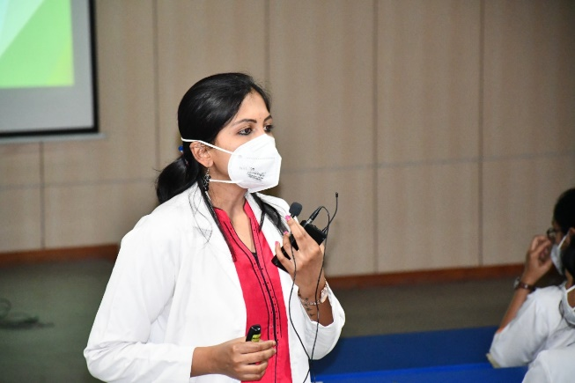
Anchor- Miss. Gayatri Brahmandam Dr. Shakthi R
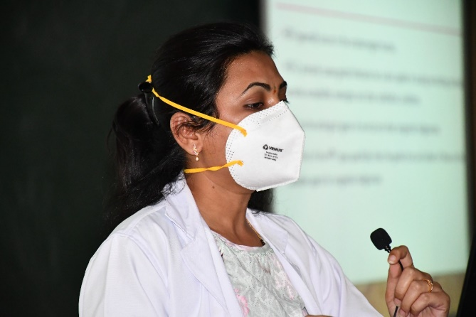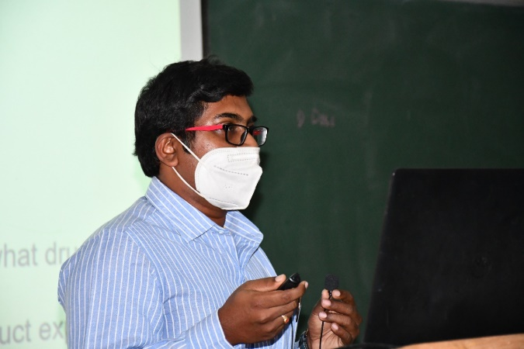
Dr. Priyadarshini Dr. Yogesh D

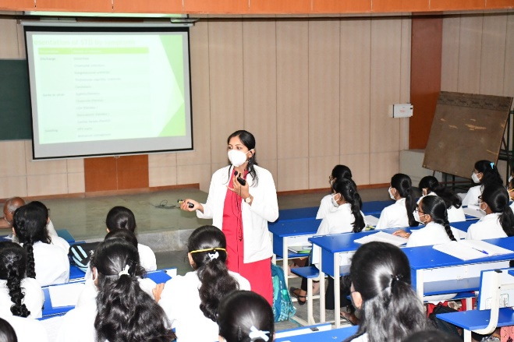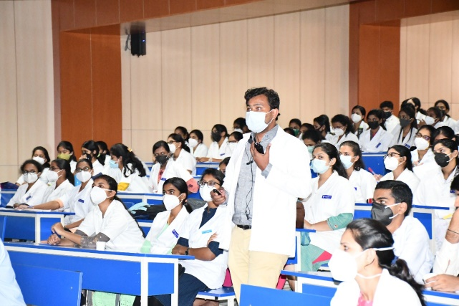
Dr. Shakthi R Dr. Vivekanand

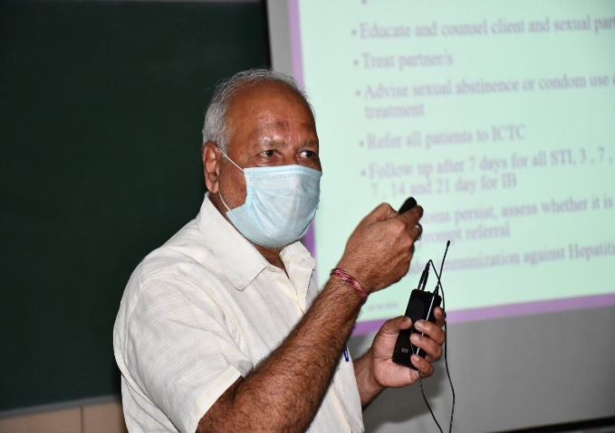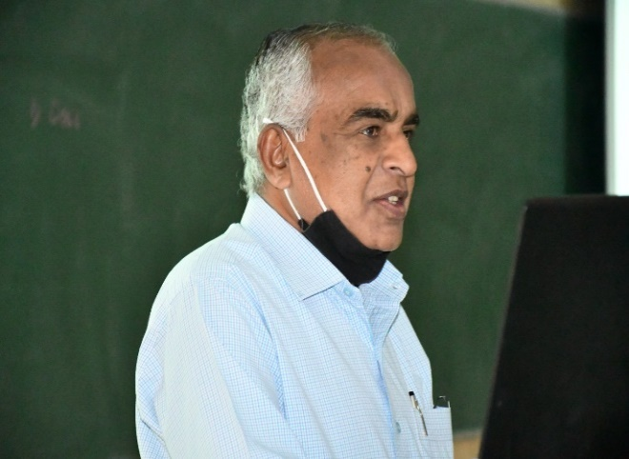
Dr. Basavaraju M. Ingalgeri Dr. Venkatesha D

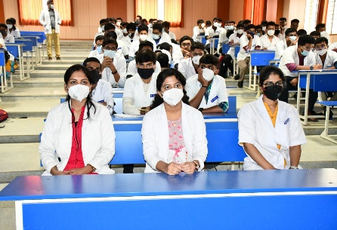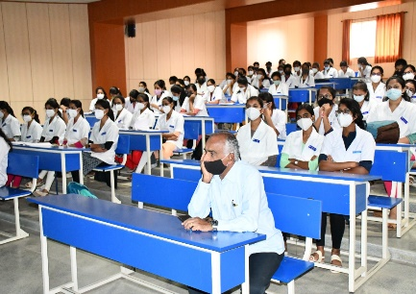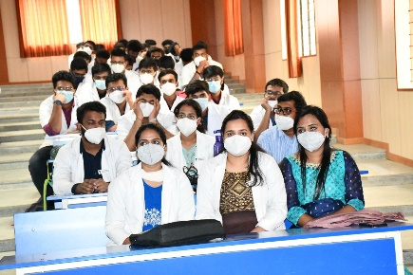

Faculty & Students

