Date: 30.12.2021
REPORT OF THE WEBINAR ON ‘STRONG STUDENT SUPPORT - KEY TO DYNAMIC STUDENT PROGRESSION’

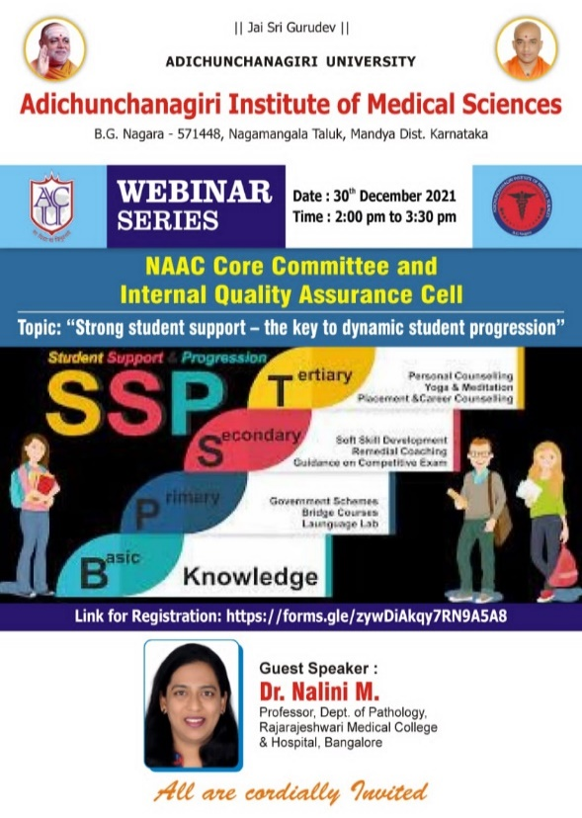
Institutional NAAC & IQAC jointly organized a Webinar on “Strong student support-the key to dynamic student progression” on 30th December 2021 between 2 to 4 PM on Google Meet platform with the link:
meet.google.com/dmz-gsmk-gvx
The webinar was attended by the Dean Academics Dr. Rupnarayan, ACU, Principals of all the ACU Constituent Colleges, Heads and faculty members of various departments and members of committees of AIMS such as, NAAC core committee, NAAC steering committee, IQAC team, grievance redressal cell, sexual harassment prevention committee, antiragging committee, student council and alumni association.
The webinar begun with the welcoming of Dr. MG Shivaramu, the Principal, AIMS in his absence and Dr. Nalini M, the Guest speaker and the delegates by Dr. Ravi GC, Professor of ENT department. It was followed by the keynote address by Dr. Sudhir GK, Professor & Head, Physiology & IQAC Co-Ordinator followed by the introduction to speaker by Dr. Vinaya M, Associate Professor, Pharmacology.
The resource person for the webinar, Dr.Nalini M, Professor, Dept of Pathology, Rajarajeshwari Medical College and Hospital, Bangalore took over the session and the presentation was comprehensive, insightful and an interactive one. She explained all the metrices under each key indicators in detail. The questions and doubts raised by the delegates were answered clearly by the speaker. Dr Aliya Nusrath, NAAC coordinator, concluded the session with vote of thanks.
The session was recorded with the permission of the Guest speaker and the delegates. The webinar recording can be accessed with the link provided below: https://drive.google.com/file/d/1N6weOOLuCWTtjLvEksueNnNfJAXL6dm/view?usp=sharing

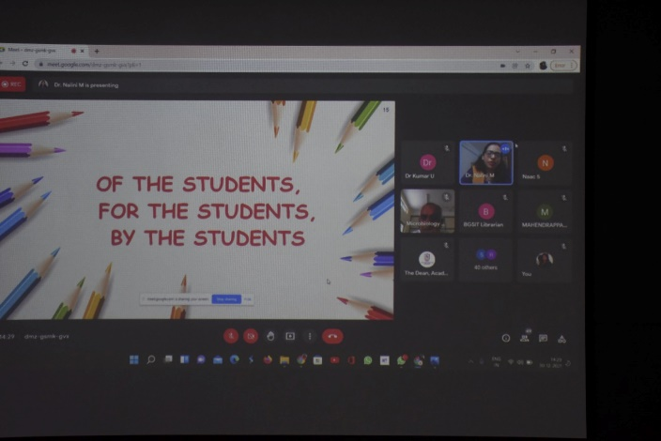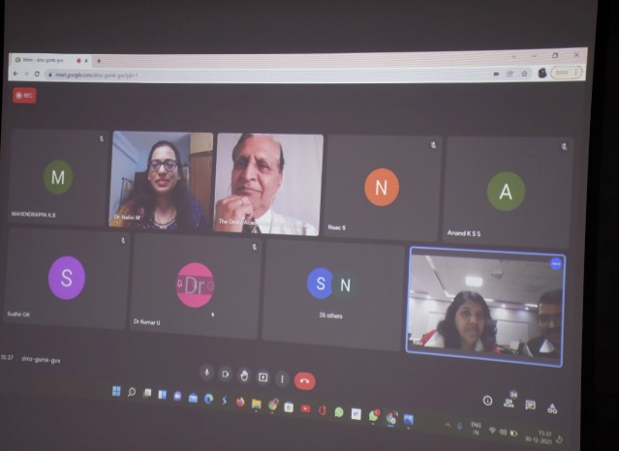
Powerpoint Presentation by the Guest Speaker Webinar Screenshot
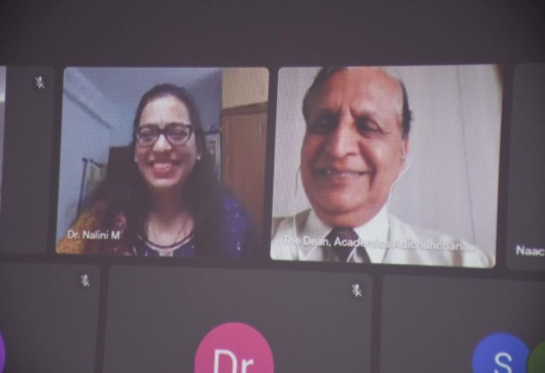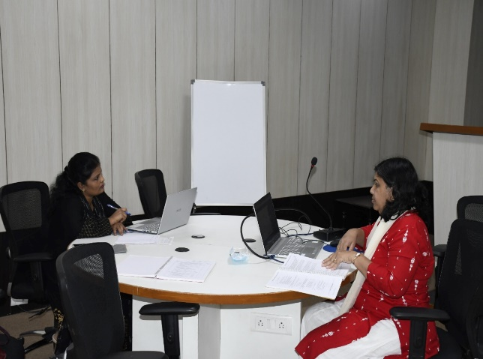
Dr. Rupnarayan, Dean (Academics) in conversation Dr. Aliya Nusrath and Dr. Vinaya M
with Dr. Nalini M, the Guest Speaker
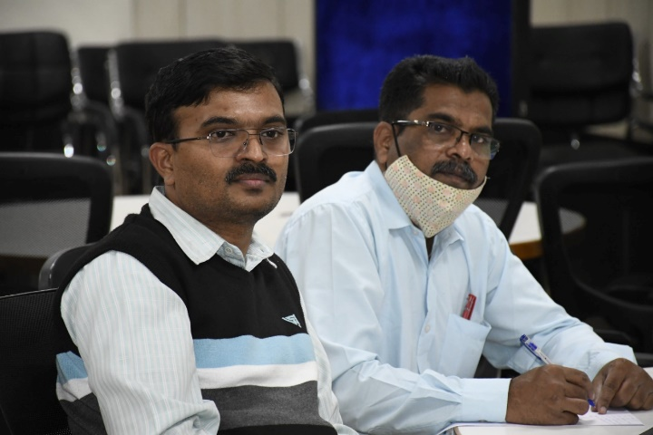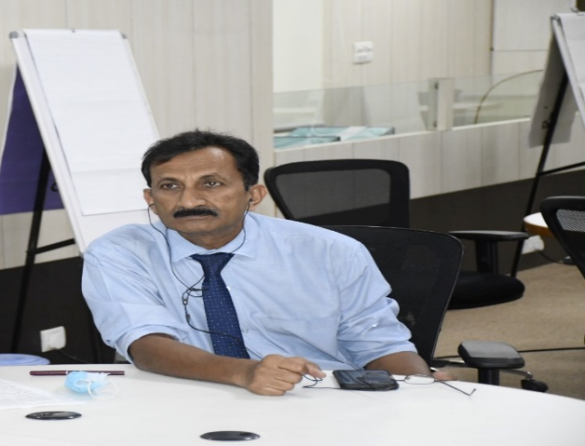
Dr. Sudhir GK, IQAC Coordinator Dr. Ravi GC in the webinar
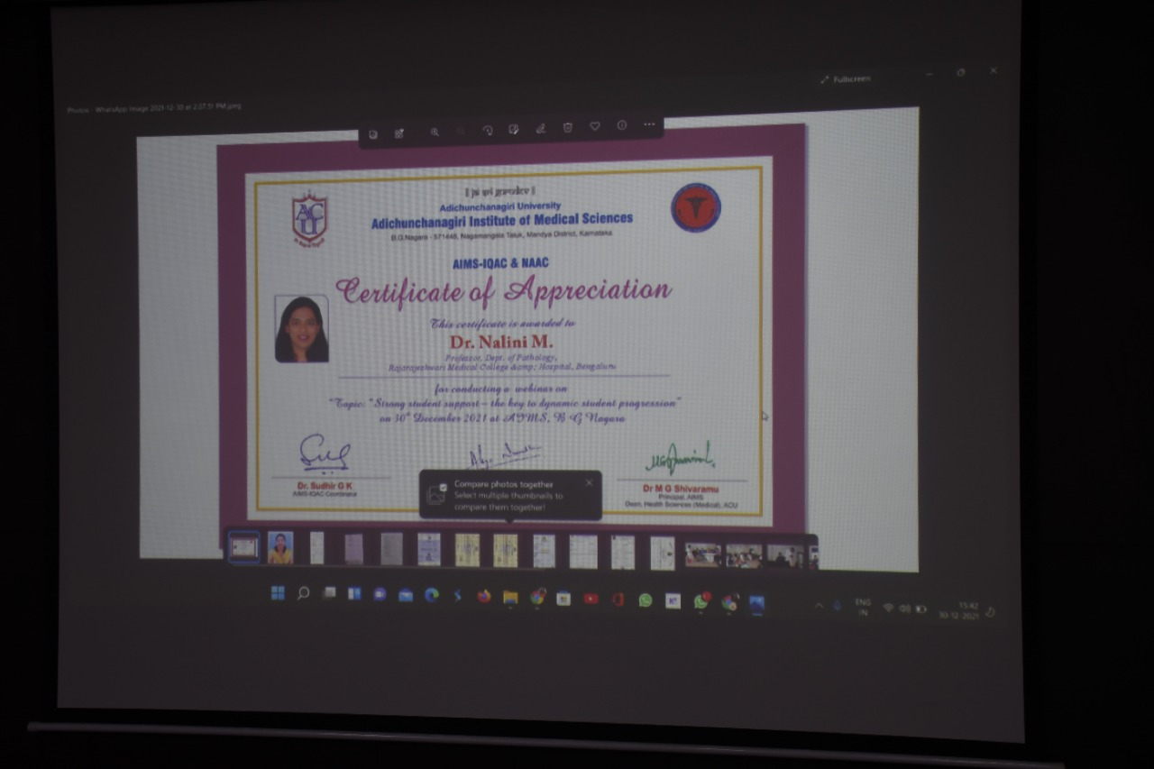
Certificate of Appreciation for the Guest Speaker
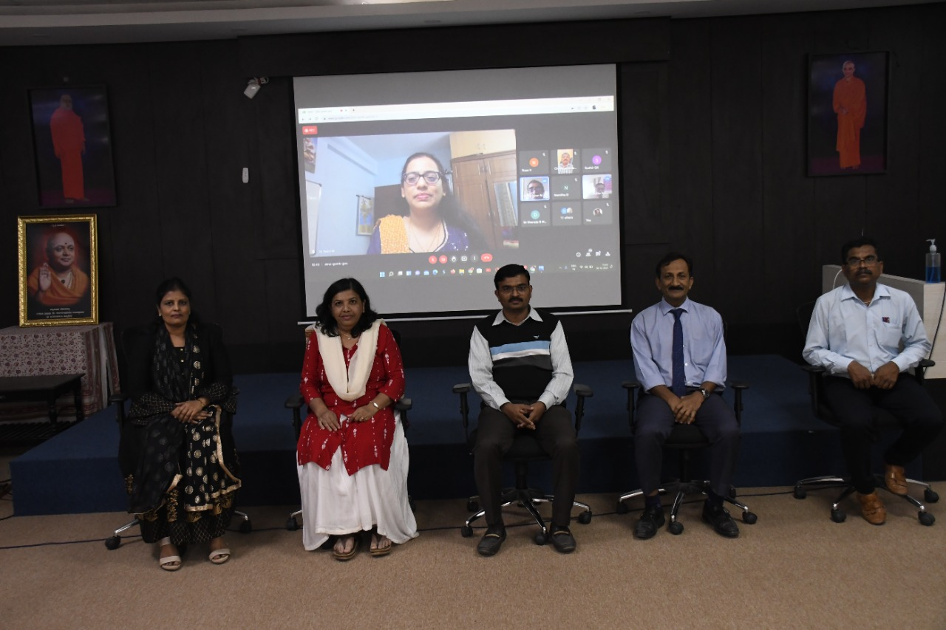
Webinar Hosting Team with the Guest Speaker Online

*************

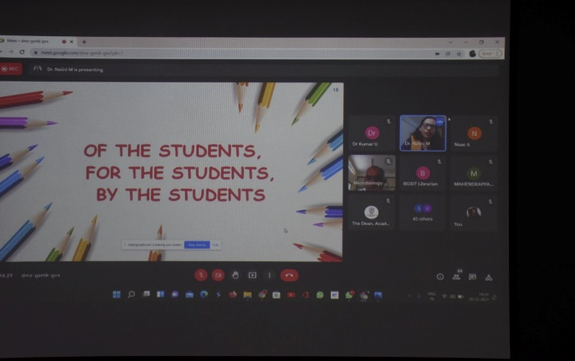
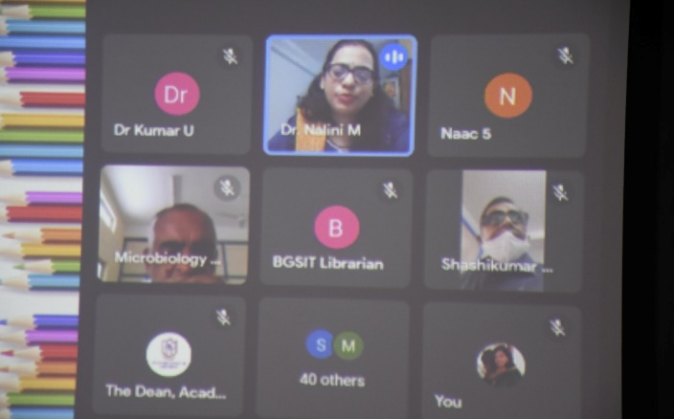
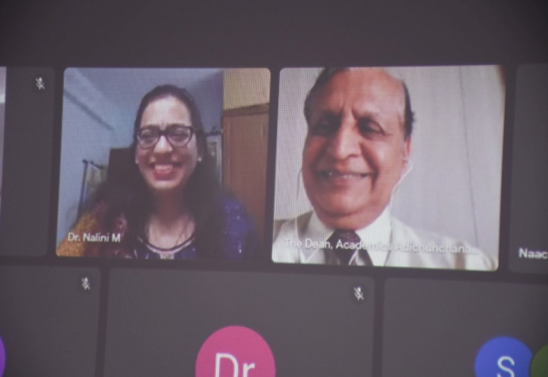
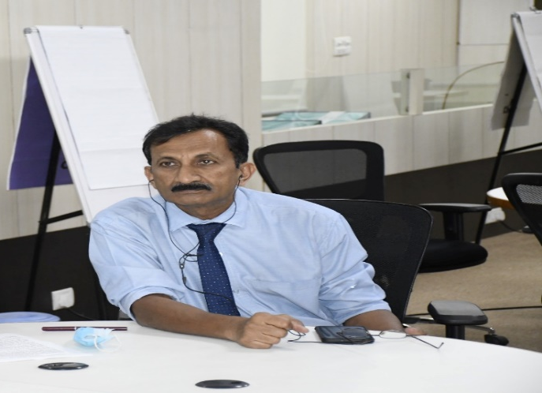
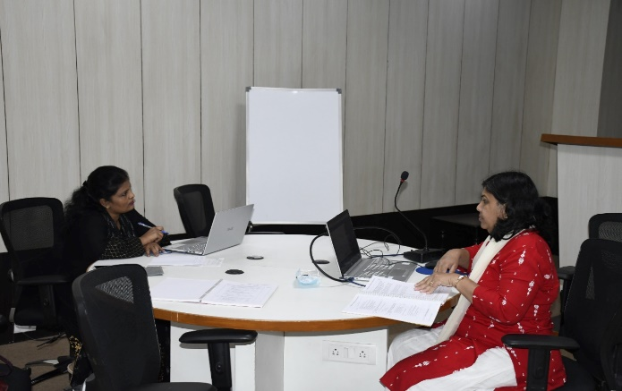
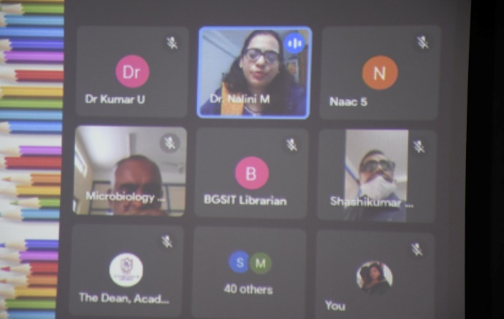
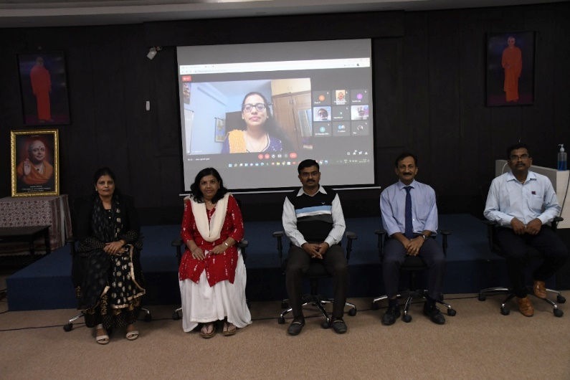
Webinar screenshot
Dr. Rupnarayan, Dean (Academics) in conversation with the Guest Speaker
Dr. Sudhir GK, IQAC Coordinator
Dr. Ravi GC in the webinar
Dr. Aliya Nusrat and Dr. Vinaya in the webinar

