SCIENTIFIC COMMITTEE
Report on “Workshop on basics in research methodology and statistical analysis using SPSS software”

This Program was conducted on 30th Nov nd & 1st Dec 2021 by Scientific committee, AIMS at MEU Hall l, ground floor, AIMS.
This program was planned by Scientific committee. The faculty for the workshop were Dr Praveen Kulkarni, Assistant Professor, Dr Smitha MC Assistant Professor, Mr Arun Gopi, Lecturer from department of community medicine from JSS Medical college, Mysore, along with scientific committee member, AIMS, Dr Amita K Professor Pathology.
The workshop began with formal inauguration by an invocation song by Miss Anarghya, 3 ^{rd} term MBBS student. Dr Amita K, Professor of Pathology & Coordinator Scientific committee welcomed the gathering with the introduction of the guest faculty. Guest faculty were felicitated by our beloved principal Dr MG Shivaramu who also delivered the presidential address.
Dr Aliya Nusruth, Professor & HOD Biochemistry delivered vote of thanks.

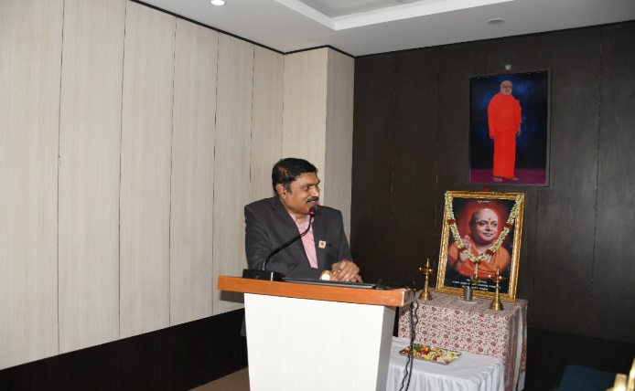
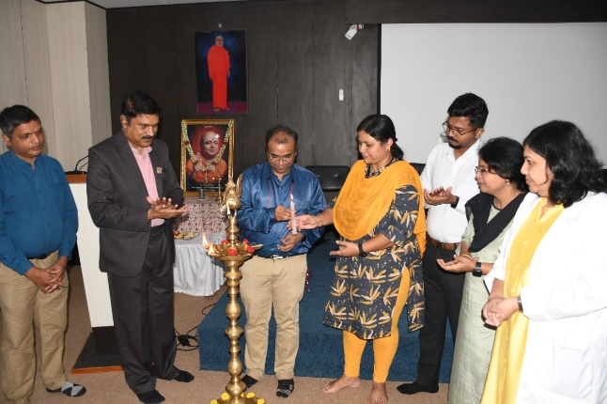
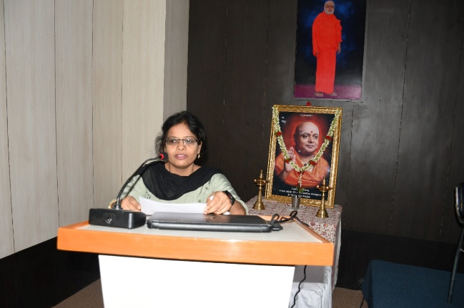

This was followed by an interactive talk on Day 1 on Introduction to Research Methodology, Framing a Research Question and Objectives, Literature search, Study designs, Descriptive statistics, Hypothesis testing – Basics, Sample size estimation.
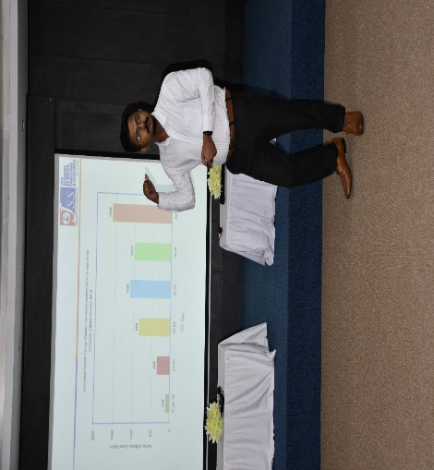
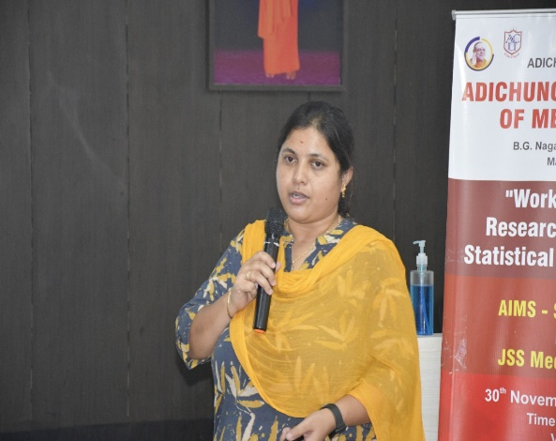
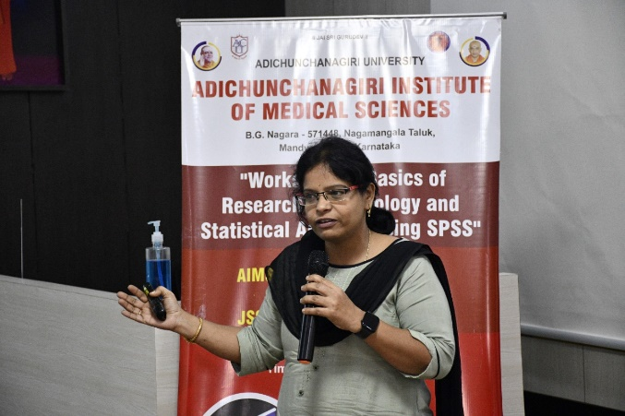
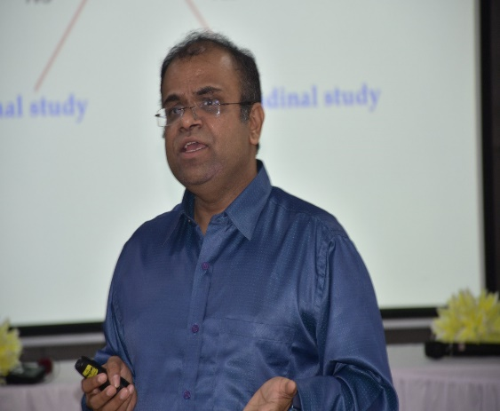
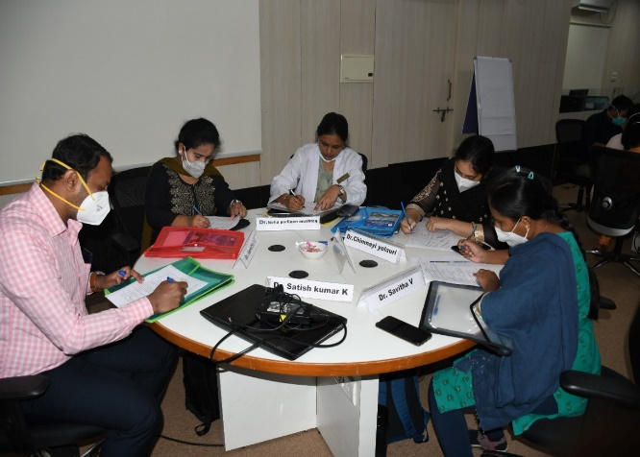

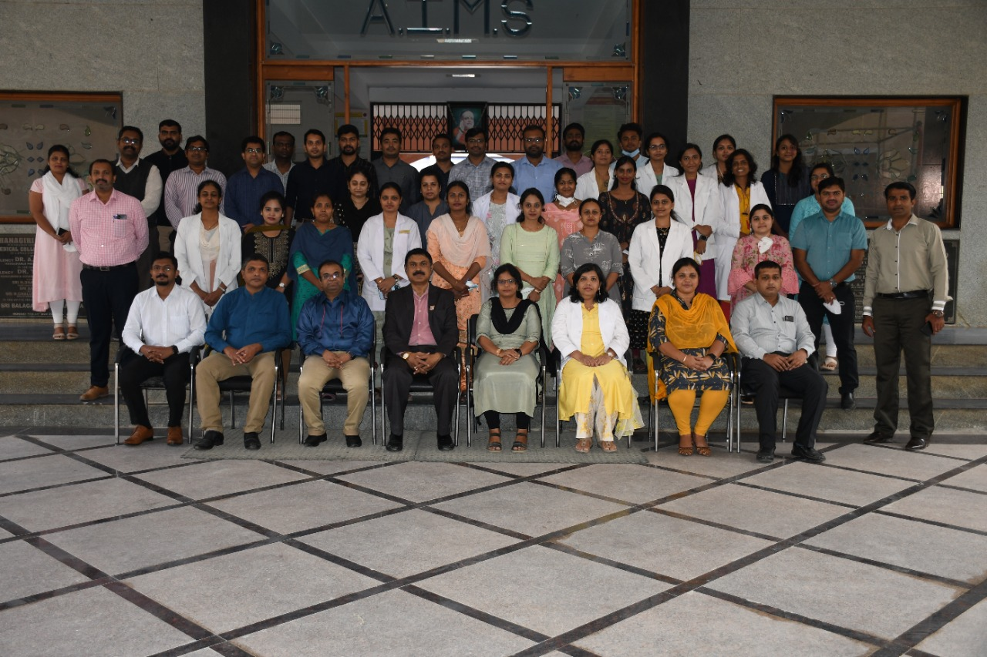

Day 2 began with the brief overview of the previous day sessions by delegates. The scientific sessions included interactive talk on sampling techniques, Inferential statistics, Introduction to SPSS Software, Correlation and Regression, how to design and validate a questionnaire & Introduction to Qualitative Research. The speakers gave a wonderful hands on training on SPSS software and group activities which were very much well appreciated by the participants. Post test and feed back was obatined from the participants. Program was fruitful as judged by the pre test post test scores, oral and written feedback.

The session ended with discussion on group activities.

A formal vote of thanks was delivered by Dr Amita K and feedback was taken from delegates and the certificates were distributed.

