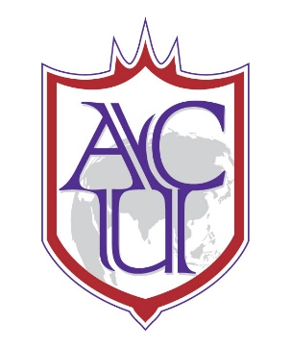
II Jai Sri Gurudev II
ADICHUNCHANAGIRI UNIVERSITY 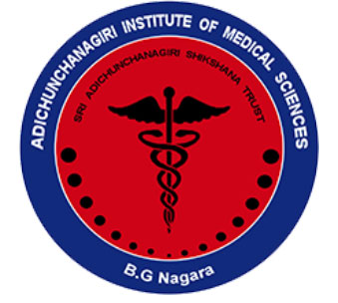
SUMMARY REPORT OF THE ORIENTATION PROGRAMME (WEBINAR) ON INDIAN COUNCIL OF MEDICAL RESEARCH – SHORT TERM STUDENTSHIP – (ICMR-STS) PROJECTS FOR ALL MBBS STUDENTS

Adichunchanagiri Institute of Medical Sciences, B G Nagara, 14TH JANUARY 2022
Introduction: In recognition of the need for enhancing the research orientation in undergraduate students the Scientific Committee had organized a training workshop on “ORIENTATION PROGRAMME (WEBINAR) ON INDIAN COUNCIL OF MEDICAL RESEARCH – SHORT TERM STUDENTSHIP – (ICMR-STS) PROJECTS” on 14TH JANUARY 2022 in Adichunchanagiri Institute of Medical Sciences, B G Nagara. 160 undergraduate MBBS of first, second and third phase students and junior and senior faculty members attended this Webinar
Background and Objective: Undergraduate students generally do not have orientation towards medical research. To orient undergraduate students towards research methodology Indian Council of Medical Research has been conducting Short term studentship projects since many years. Hence the workshop was organized to orient undergraduate students towards starting projects works as per ICMR guidelines

Dr. Amita K, Co ordinator Scientific committee, delivered welcome speech and opened the meeting by introducing the workshop background and objective. Dr MG Shivaramu, Principal, AIMS, Dean , Health Sciences (Medical) , ACU adressed the delegates, highlighted the salient features of STS-ICMR program and motivated them to take up research projects. Dr. Aliya Nusarath , professor and HOD of department of Biochemistry delivered talk introducing ICMR STS projects and gave a detailed walkthrough towards starting the project work

The workshop was attended by all 160 MBBS students and faculty members of AIMS who were very enthusiastic in learning about ICMR STS projects Dr. Vinay S Bhat Thanked Dr. Aliya nusarath for delivering excellent talk on orienting students regarding ICMR STS projects

Dr. Tejaswi HL delivered vote of thanks at the end of the webinar and motivated students to take up ICMR STS projects
Workshop concluded with the note to the students regarding conducting further workshop specifically targeting students who have registered for ICMR STS workshop , which will be held once the registration process for projects gets completed
Glimpses of the Program

