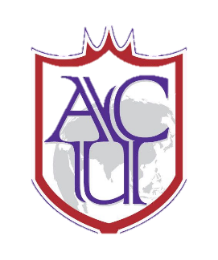
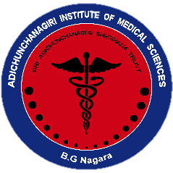
II Jai Sri Gurudev II
Adichunchanagiri University
Adichunagiri Institute of Medical Sciences

REPORT OF DESSERTATION WRITING WORKSHOP FOR SECOND YEAR POST GRADUATE STUDENTS OF 2020-21 ON 3rd AND 4th MARCH 2022
Introduction: In recognition of the need for enhancing the dissertation writing skills of the post graduates, the Scientific Committee had organized a training workshop on “Dissertation writing” on March 3rd and 4th 2022 in Adichunchanagiri Institute of Medical Sciences, B G Nagara at Lecture hall 1. Sixty seven postgraduates attended the workshop.
Background and Objective: Postgraduate students in Medical colleges rarely receive training in research methodologies which is very essential to approach their dissertation or any other research with confidence.
The objective of the workshop was to strengthen participants’ understanding of scope, methods, and the rationale behind effective dissertation writing.
Summary of the programme:
Program began at 9:00 AM with registration & administering pre-test questionnaire to the participants. Dr Amita K, co ordinator scientific committee, delivered the welcome address. The program was inaugurated by Dr MG Shivaramu, Dean Health sciences (Medical), ACU and chairman of scientific committee by delivering the presidential address. Dr Vinay Bhat Professor (ENT) delivered vote of thanks. The workshop included ten interactive scientific sessions on different aspects of dissertation writing including introduction & Objectives by Dr Aliya Nusrath, Professor & Head of Biochemistry. How to perform literature search was dealt by Dr Dhanalakshmi TA, Professor of Microbiology. Dr Aliya Nusrath covered the exhaustive topic of how to write Review of literature. Wriiting methodology was dealt by by Dr Radha R, Professor and Dr Sheetal MP, Assocaite Professor, community medicine, while Data organization and analysis was covered by by Dr Shashikantha SK Associate Professor community medicine.,
Day 2 began with registration and reflections of day 1 by postgraduate students. The day began with topic of How to write results by Dr Amita K, Professor of Pathology, Writing Discussion and Conclusion, abstract, summary was covered by Dr Tejaswi, Professor of Anatomy.This was followed by session on reference writing and Plagiarism and language skills by Dr Vinay Bhat,Professor of ENT.Dr Tejaswi HL briefed upon the journey of dissertation to publication.
The program concluded with post-test, feedback and distribution of certificates by Principal. The programme was well received by the postgraduates.
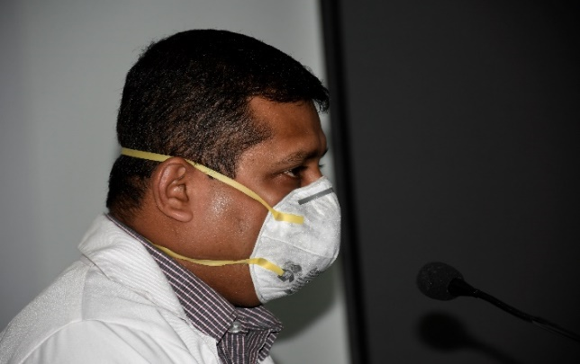
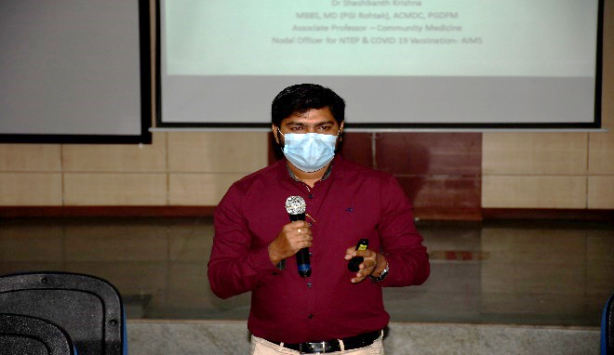
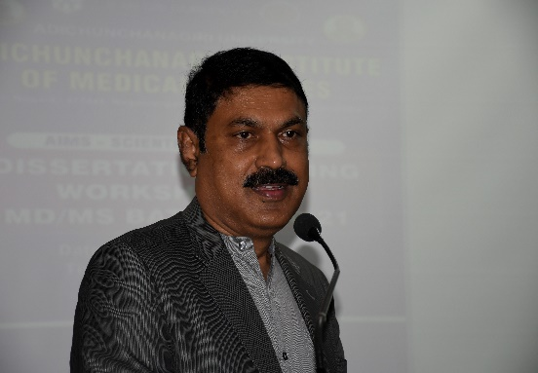
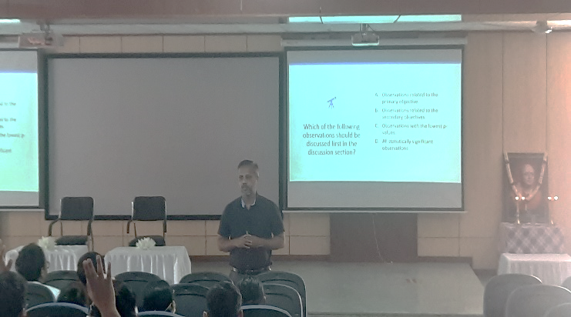
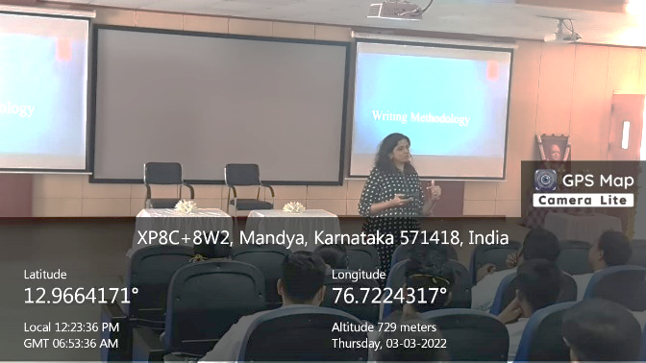
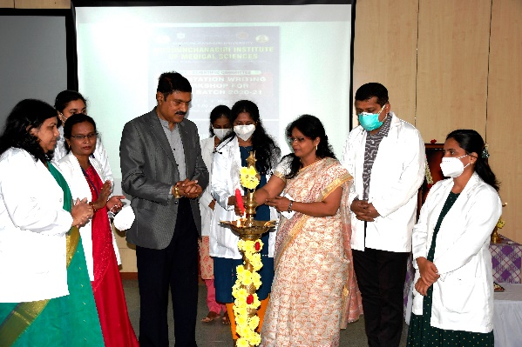
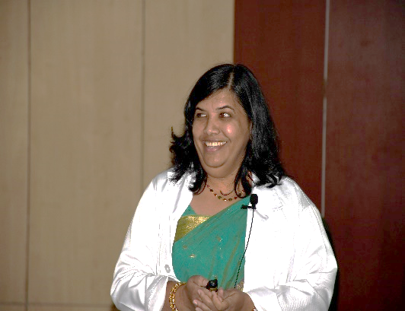
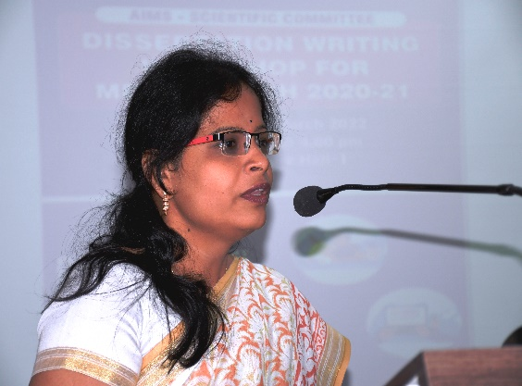
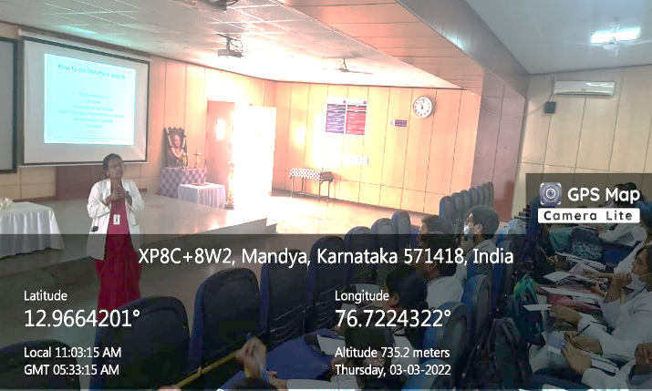
Glimpses of the inauguration and the Scientific Sessions on both the days of Workshop
