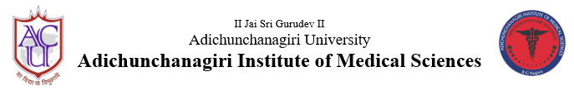
B G Nagara: 571448, Nagamangala taluk, Mandya district, Karnataka

Department of Physiology
UG Orientation programme for I M.B.B.S., 2021-22 Batch
Date & Time of programme: 13/4/22, 9:00 am to 4:00 pm
Venue: Seminar hall (Morning sessions) and Lecture Hall 1(Afternoon sessions), A.I.M.S,
B.G. Nagara

Participants: First M.B.B.S. students (143) and Physiology Department staff (teaching & non-teaching)

SUMMARY

An Orientation Programme was organized the by department of Physiology, AIMS on 13/4/22 for I MBBS 2021-22 Batch with the objective to make students familiar with the department, its academic and administrative rules and policies.
The programme started with a general welcome of all participants by Dr. Smitha. N, Assistant Professor, Department of Physiology (Programme moderator). Session began with the invocation song by Miss Varshitha B.H & Miss Varalakshmi B. I MBBS students followed by, Inauguration of the program by lamp lighting and offering Pranams to Poojya Guruji by all the teaching, non- teaching staff of the department and students.
Key note address and Staff introduction (10:00-10:10 a.m.): Dr. Sudhir G.K. (Professor &HoD), Physiology delivered key note address, spoke about sequence of sessions, roadmap for training in human physiology, discussed about master time table and introduced all the staff members with their designation.
Physiology curriculum and Overview (10:30 – 11:00 a.m): Dr. Ravi G.N (Associate Professor), Physiology, spoke about broad goal of teaching Physiology to undergraduate students, also provided insight on competency based medical education, teaching hours’ distribution in subject
Textbooks & Learning Resources from the department (11:00 -11:15 a.m.): Dr. Ravi G.N (Associate Professor) Physiology, spoke about various textbooks prescribed for students for basic reading, references & practical. He also provided information about learning resources like blue books, clinical kit, chart case history booklet, practical record which will be facilitated by the institution and department.
Curriculum implementation methods (11:15-11.45am): Dr. Sudhir G.K. (Professor &HOD), Spoke about various teaching methods like lecture, seminars, tutorials, group discussions, seminars, ECE, AETCOM, SDL which will be organized in the department.
Ram-navami Pooja (11:45-12.15pm): Students attended Sri Ram-navami Pooja at administrative office and followed by refreshment.
Assessment methods & criteria for eligibility and pass (12.30-1.00 pm): Dr. Malini.M, Assistant Professor, spoke about evaluation methods like unit test & internal assessment in both theory & practical & she also spoke about eligibility criteria to take university exams & criteria for passing the same.
Refreshment activity (2.15-2.40pm): Students were made to involve in fun activity for refreshment. The arranged activity was Pick & Act, singing, constructing pyramid and games. The students were actively involved.
Mentorship programme (2:40 - 3.00pm): Dr. Divyashree, Assistant Professor spoke about the method for division of students under the tutor-ward system in the department. Also informed about the objectives of mentorship programme and responsibility of mentor and mentee.
Department Rules & Regulations (3:00 p.m-3:20 am): Dr Santosh K Mayannavar
Assistant Professor, spoke about rules of the Department mainly he stressed upon maintaining proper discipline in the campus, dress code, time of entry to teaching session, attendance criteria to attend Internal and as well as for University exams.
Co-curricular & Extra-curricular activities (3.20 p.m-3.40 pm): Dr. Malini.M, Assistant Professor, talked about various Co-curricular activities like UG quiz, Jnana vignana tanthragnana mela (JVTM), essay competition & research activity in the department. Extra-curricular activities like ganesha fest, Dr .Rajagopal sir birthday celebration & sports week.
Programme concluded with reflection about the orientation programme by the students.

Vote of Thanks: The programme concluded with a Vote of Thanks proposed by Dr. Smitha.N, Assistant Professor of Physiology.

Physiology orientation programme
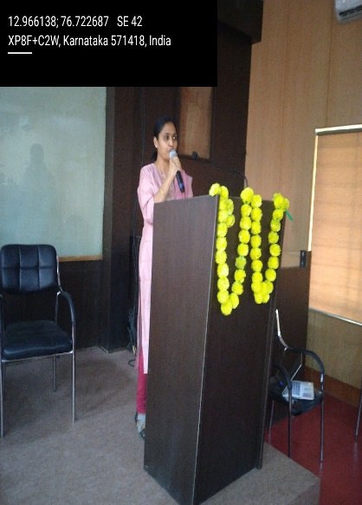 | 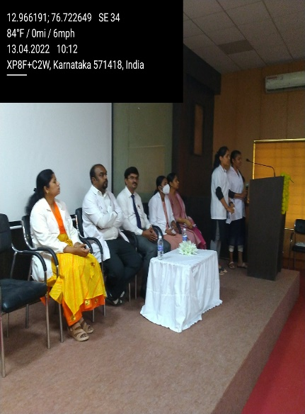 |  | 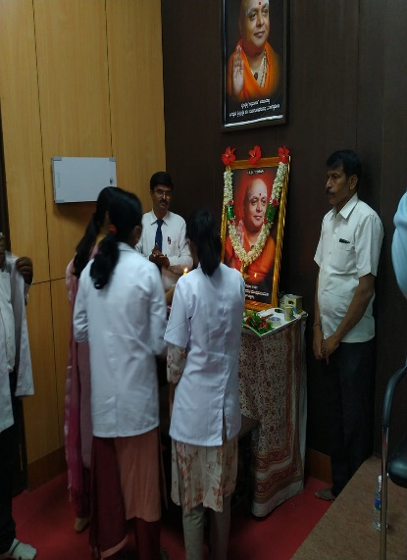
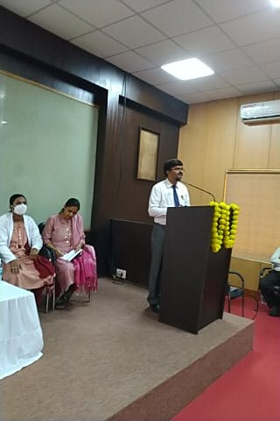 | 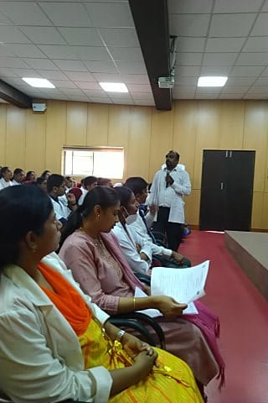 |  | 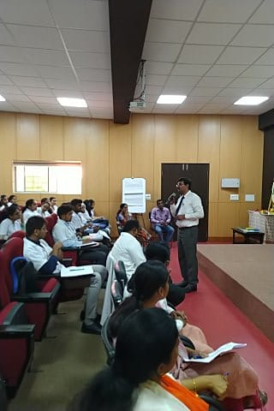
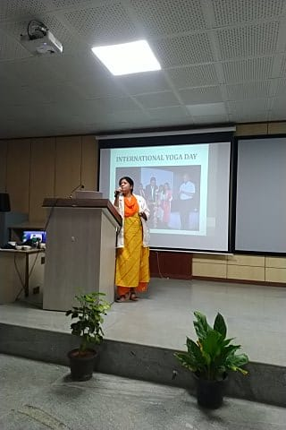 | 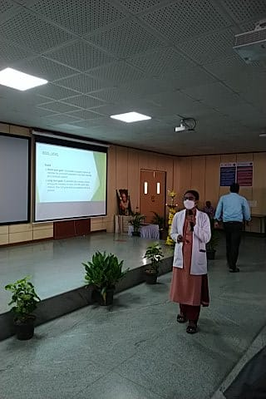 | 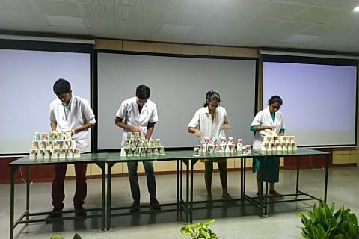

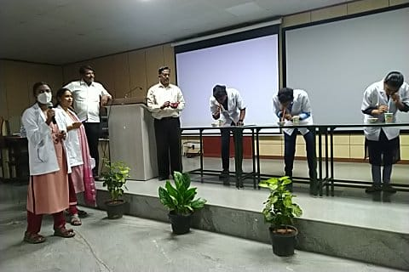 | 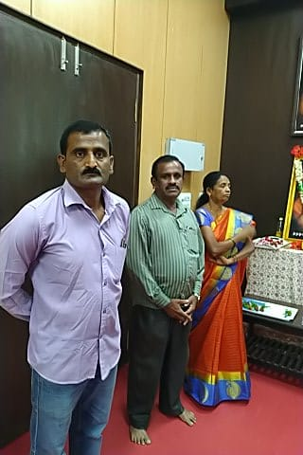
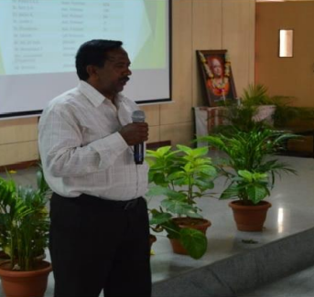 | 