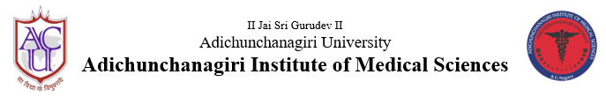
B G Nagara: 571448, Nagamangala taluk, Mandya district, Karnataka

Department of Community Medicine
Eye camp and awareness programme
13th April, 2022
Department of Community Medicine in association with Department of Ophtalmology, AIMS had organized a Eye camp and awareness programme on the occasion of Prevention of blindness week on 13th April 2022 at Mathrubhoomi Vriddhashrama, Channarayapatna for around 75 old age people. The main objective of the programme was to screen old age persons for cataract and to increase awareness regarding blindness - causes and its prevention. Initially people were screened by Ophalmologist - Dr Vineel and house surgeons from the department of ophthalmology followed by awareness programme by staff of Community Medicine. Programme schedule was as follows
Sl.no. | Topic | Speaker
1. | Blindness - causes and prevention | Dr Manuja LM,  Assistant Professor,  Department of Community Medicine
2. | Health care of the old aged - problems and management | Dr Prabhudeva M C  Medicosocial worker  Department of Community Medicine

A total of 75 residents of old age home participated in the event and were given snacks after the programme. The programme was organised under the guidance of Dr Shivaramu MG, Principal, AIMS, Dean, Health . Special thanks to Mr and Mrs Naganna, Head of Onde MatharamTtrust.

