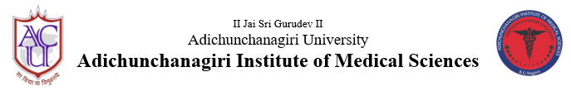
B G Nagara: 571448, Nagamangala taluk, Mandya district, Karnataka

Student Support Cell
Sensitization programme on recent updates of NTEP

March 29, 2022
NTEP AIMS unit in association with Student Support Cell, AIMS had organized a sensitization programme on NTEP (TB) recent updates on 29th March 2022 at 3pm in Lecture Hall 1 at AIMS. The main objective of the session was to sensitize the under-graduates about the burden of Tuberculosis in our country, revised NTEP guidelines to diagnose and manage the tuberculosis patients in co-ordination with the NTEP cell of our institution. The students were addressed about the NTEP functioning and the mistakes that can be rectified at the earliest to prevent delay in diagnosis and treatment initiation. The Programme schedule followed was-
S.no. | Topic | Speaker
1. | Introduction (TB and NTEP) and problem statement of TB in India | Dr Shashikantha SK, Associate Professor and NTEP Nodal Officer,  AIMS-B G Nagara
2. | Diagnosis of TB including MDR TB | Dr Manuja LM, Assistant Professor, Coordinator, SSC, AIMS
3. | Treatment and prevention of Tuberculosis and management of MDR TB in brief | Dr Sheethal MP, Associate Professor, Department of Community Medicine, AIMS

A total of 120 students (3rd Term) participated in the event. The programme was organised under the guidance of Dr Shivaramu MG, Principal, AIMS. Special thanks to District Tuberculosis Officer, Mandya and State TB Task force chairman -Dr Balu P S. Dr Madhura MM, Dr Shwetha and Dr Sulagna, from department of Community Medicine were also present.

