HEALTH EDUCATION
Health Education programme was organized by Dept of Community Medicine, AIMS for Polytechnic students of BGSIT, B.G.Nagara. Dr.Madhura.M.M. specially explained about maintenance of good health, educating about good nutritional intake and dietary habits, life style modification for physical fitness and avoidance of excessive use of mobiles or gadgets beyond needs and importance of yoga in maintenance of peaceful mind. Dr.M.C.Prabhudeva explained about ways to have healthy happy life style by daily good habits in the presence of Mr.Giriyappa, Principal, BGSIT, B.G.Nagara.
Venue: Polytechnic College, B.G.Nagara Date: 05-05-2022
Topic: Health education about fitness Audience: 1st year Polytechnic students

Speakers:
- Dr.Madhura.M.M., Assistant Prof. of Com. Medicine, AIMS, BG Nagara
- Dr.M.C.Prabhudeva, M.S.W., AIMS, BG Nagara
- Mr.Ravi, Health Inspector

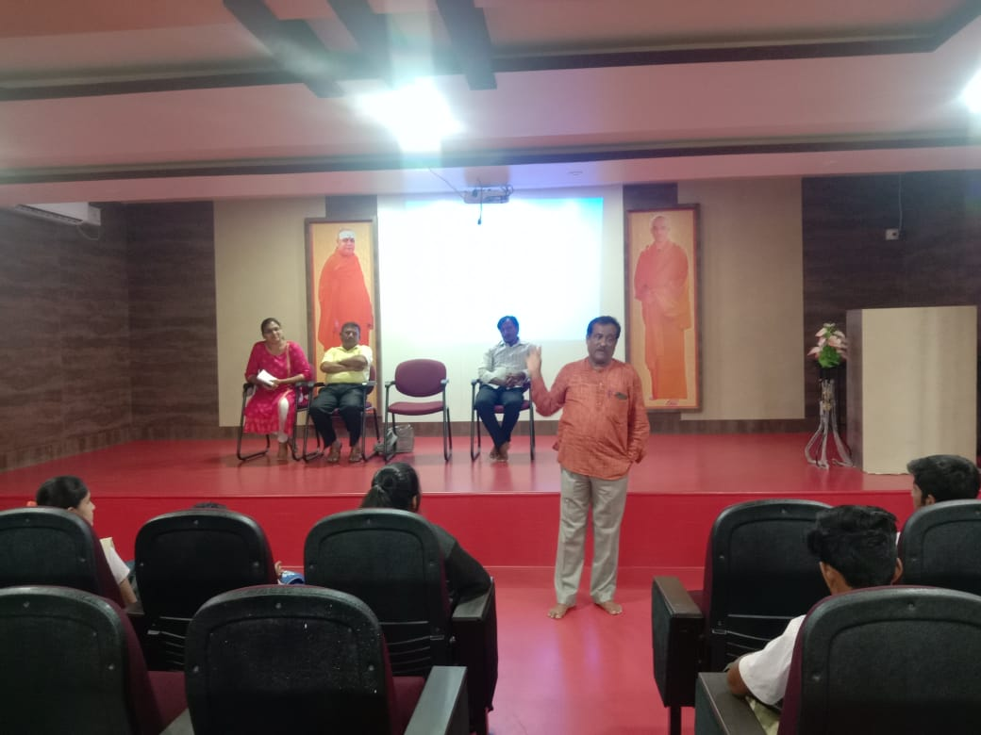
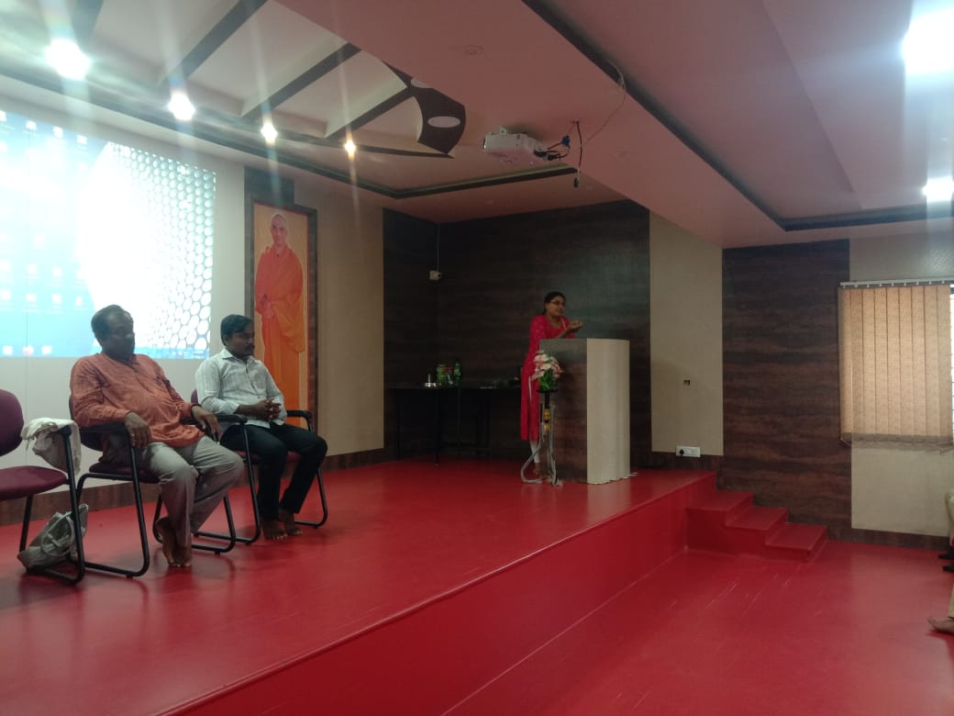
Health education at Polytechnic college, BGSIT, B.G.Nagara

