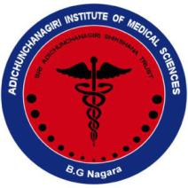
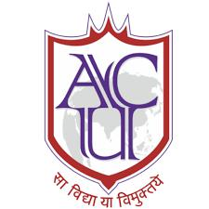
║Jai Sri Gurudev║

Adichunchanagiri University
Adichunchanagiri Institute of Medical Sciences
B.G Nagara – 571448

Department of Community Medicine
World No Tobacco Day 2022

World Health Organization created World No Tobacco Day in 1987 to draw global attention to the tobacco epidemic and the preventable death and disease it causes. From then on, the day is observed every year on 31st of May, to create awareness about the harmful effects of tobacco among public.

On the occasion of ‘World No Tobacco Day, 2022’, Department of Community Medicine, AIMS & NSS, AIMS unit in collaboration with District Tobacco Control Cell, Mandya had organised awareness program in BGS Polytechnic College, BG Nagara at 10.30 AM. Objective of the program was to educate & make students aware of the harmful health effects of tobacco and to motivate them to ‘say no to tobacco’.
Awareness activities were also organized in AIMS premises & for MBBS students, the details of which are provided in the following table.
Details of activities:
S.no. | Activity details | Speakers
1. | Awareness program in BGS Polytechnic college, BG Nagara.  A jatha by students was done followed by awareness session in the seminar hall. Guests addressed the gathering shedding light on the importance of program & stressing on the responsibility of the youth to refrain using any form of tobacco.  An oath was administered to the participants to pledge to never use tobacco in their lifetime  Handout on tobacco control & awareness was released by the guests  A skit was performed by Phase II MBBS students of AIMS  Awareness talk by Dr Amulya N, Assistant professor, Department of Community Medicine  Around 100 students had participated in the program. | Guests for the program:  - Dr Prasanna KR, Taluk Health Officer, Nagamangala  - Dr MG Shivaramu, Principal, AIMS  - Mr Giriyanna, Principal, BGS Polytechnic college, BG Nagara  - Dr Radha R, Professor, Department of Community Medicine, AIMS  - Mr Siddalingaiah, Senior health inspector, Mandya.
2. | Awareness program in AIMS premises  Rose campaign – By giving them red roses, Canteen workers & shop owners in AIMS premises were informed about COTPA rules that sale & use of tobacco in educational institutions is prohibited | Faculty of Department of Community Medicine and Interns
3. | Competition was organised for students to prepare handouts highlighting harmful health effects of tobacco in English & Kannada | 2nd & 3rd year MBBS students

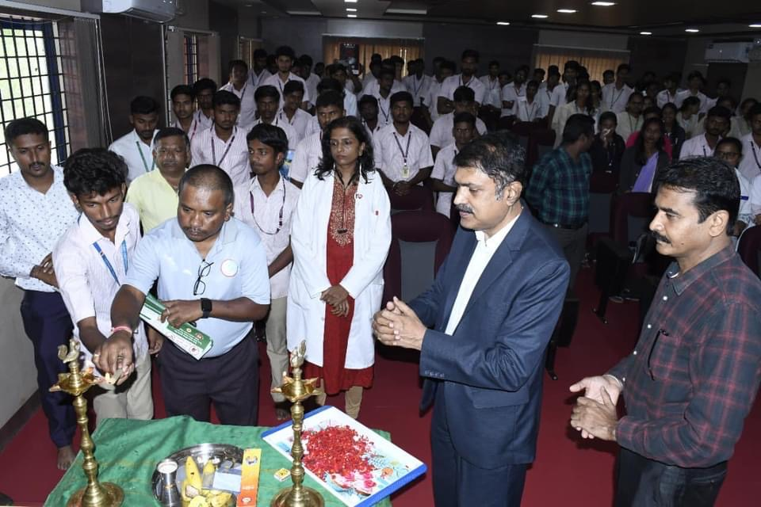
Guests inaugurating awareness program in BGS Polytechnic college, BG Nagara

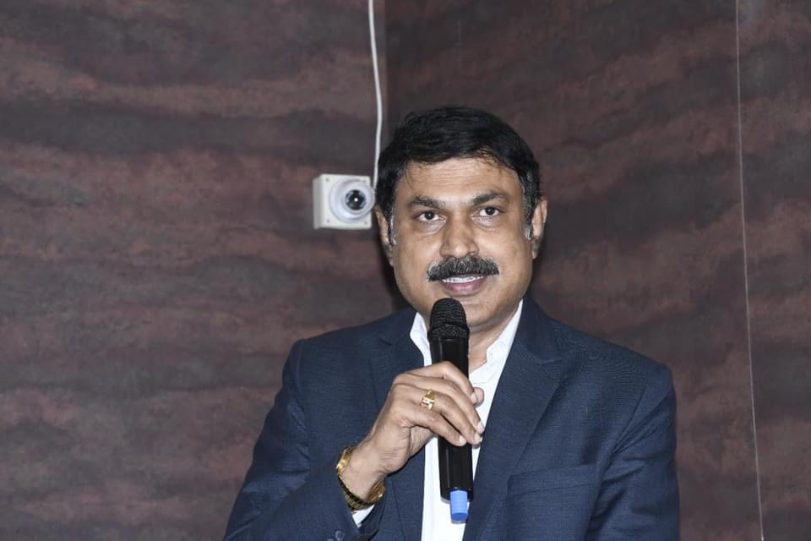

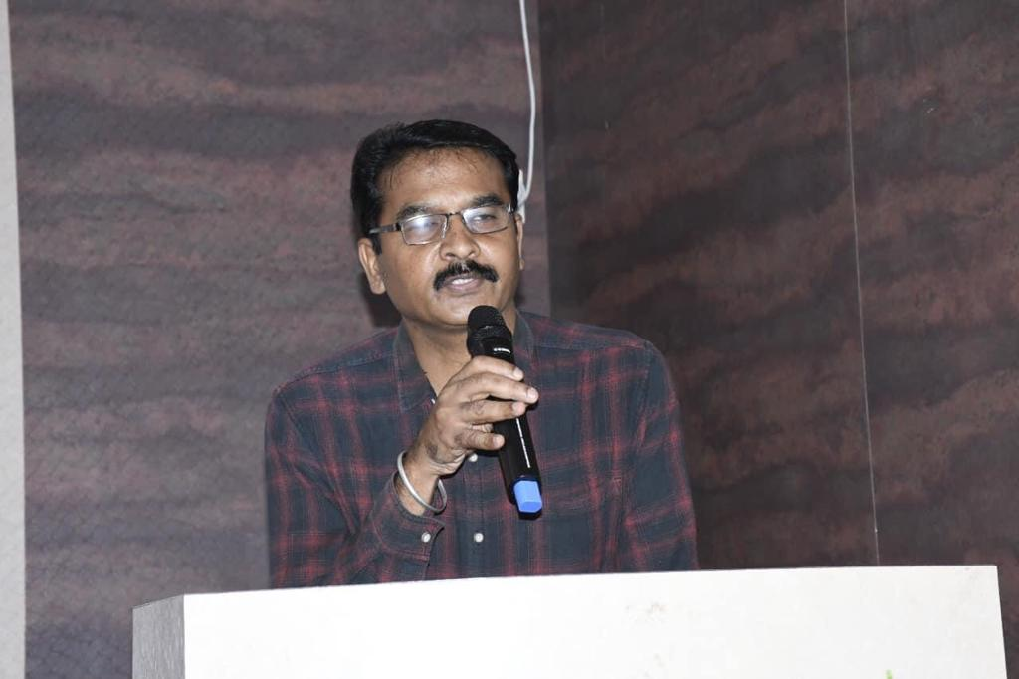
Guests addressing students in BGS Polytechnic college, BG Nagara

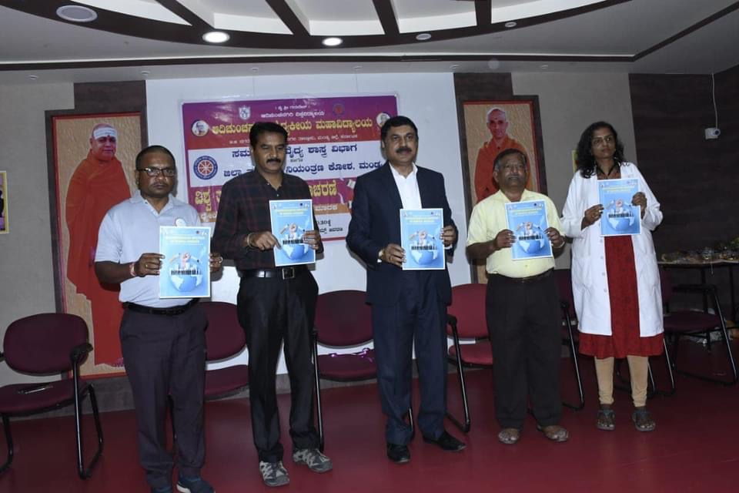
Handouts being released by the guests

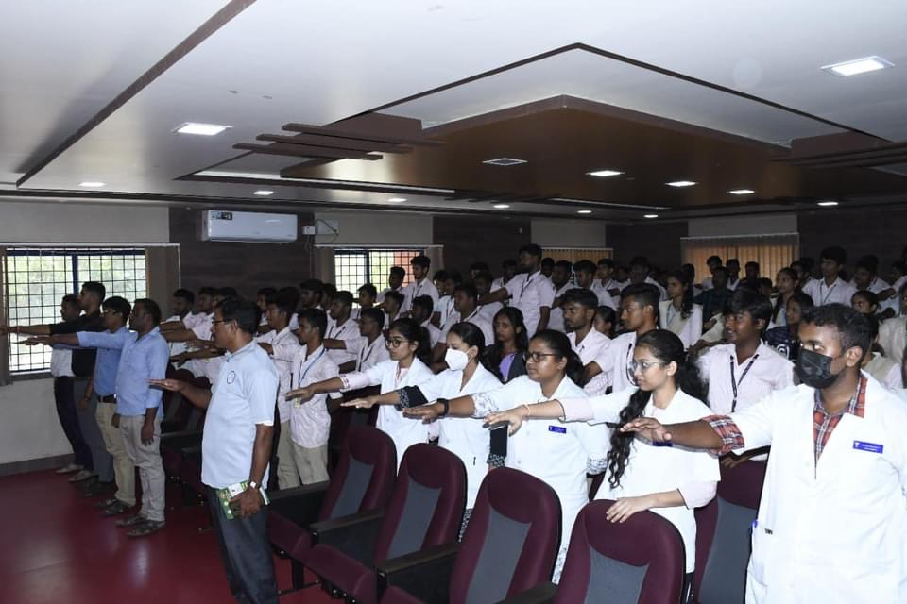
Students pledging ‘No Tobacco’ oath

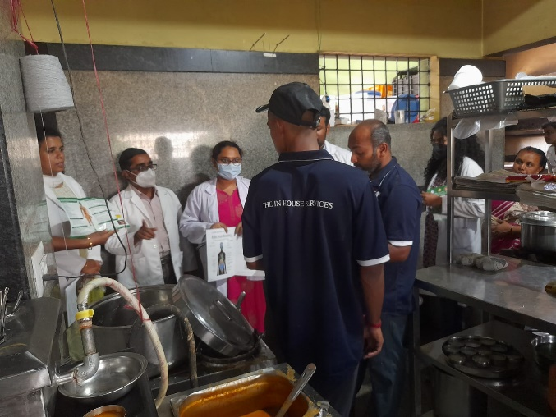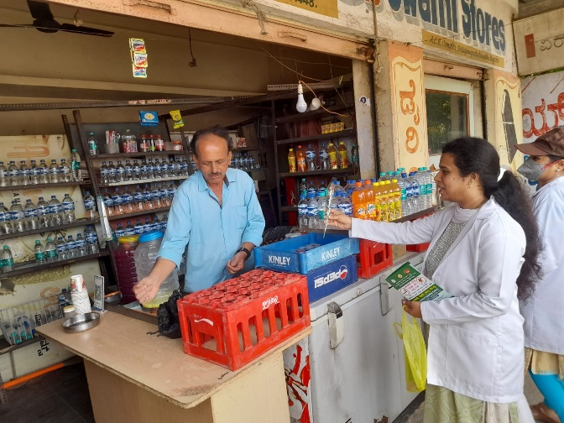
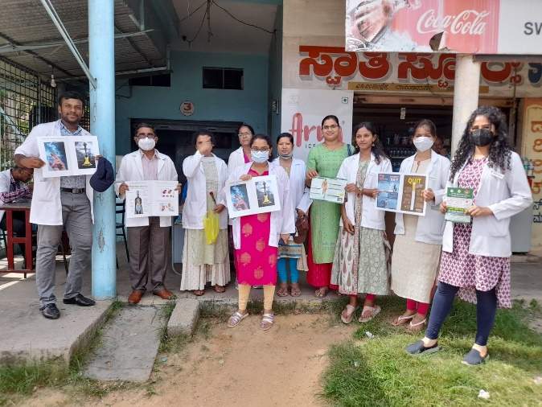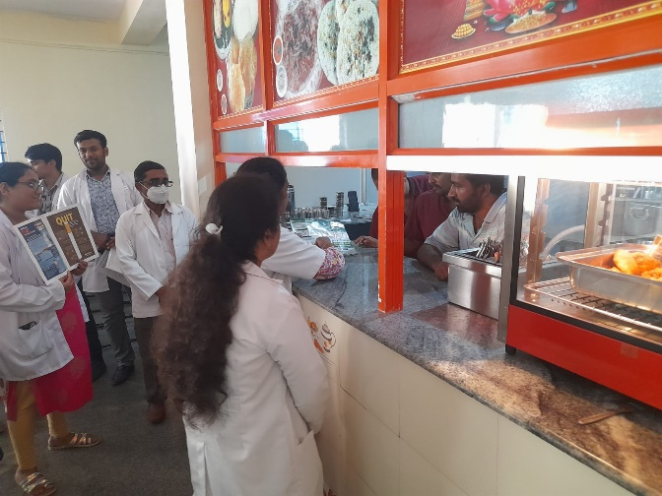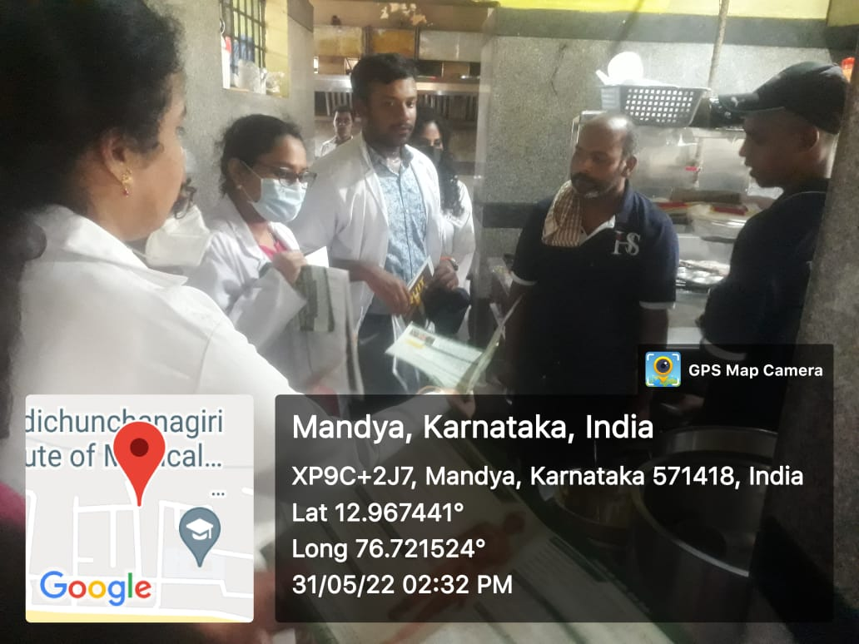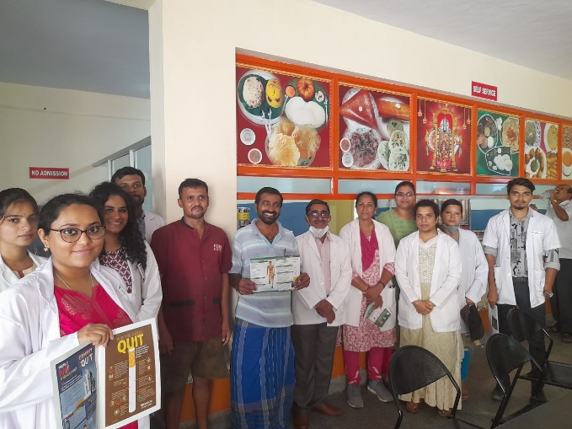
Awareness activity ‘Rose Campaign’ in AIMS premises

