Student Seminar on “Complement”
Student Seminar on “Complement” was conducted for CBME Students of Batch 2020-21 on 31.05.2022 from 11.00 am to 12.00 noon in the Lecture Hall 1. Ms. Moulya S, anchored the programme and welcomed the gathering. Ms. Anusha N Briefed the Properties of Complement. Ms. Sowmya explained the Classical complement pathway. Ms. Nayana briefed the Alternate & lectin pathway. Ms. Divyashree discussed the Effector function of complement. Ms. Haritha briefed the Complement deficiency diseases. All faculty members & 129 students attended the programme. The session was concluded with vote of thanks.

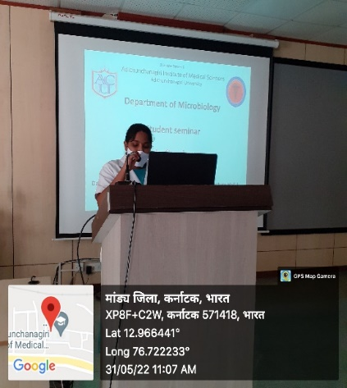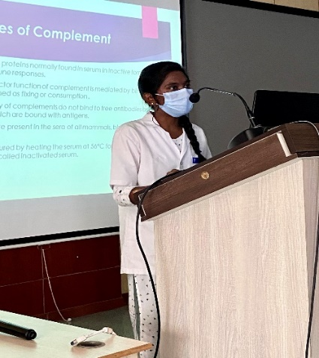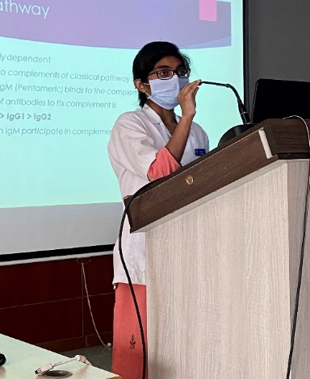
Anchor- Ms. Moulya S Ms. Anusha N Ms. Sowmya
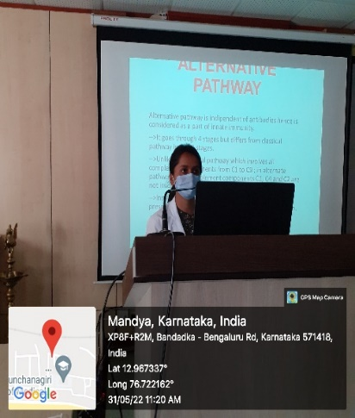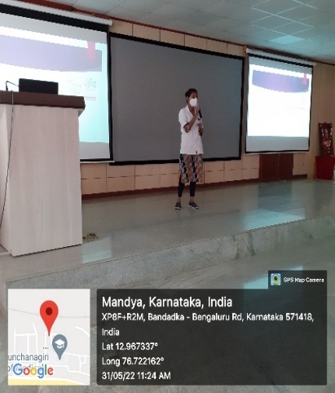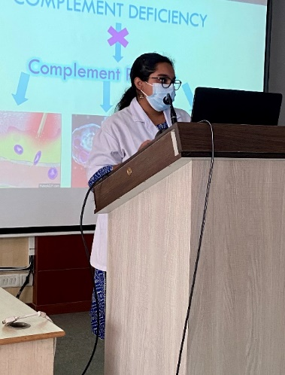
Ms. Nayana Ms. Vidyanutha N G Ms. Haritha
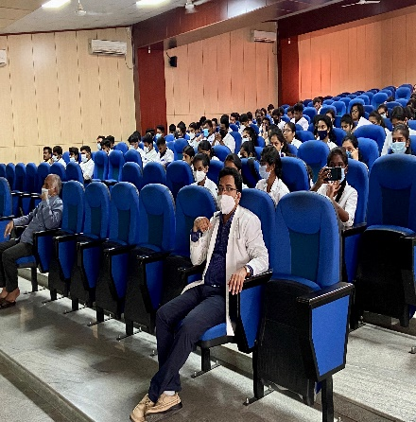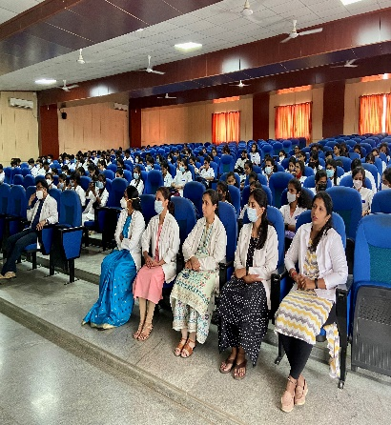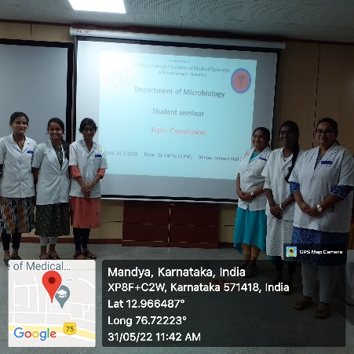
Faculty & Students

