Monthly report on Unnat Bharat Abhiyaan
We are hereby presenting the monthly report (Apr/May 2022) of the activities that we had undertaken under the banner of UBA.
It is with great delight & sense of satisfaction that we present an eventful report of Apr-May 2022. We are happy to have completed the survey in the third village namely Chakenahalli.
A major activity along with household survey was a Hypertension detection camp organized in the HPS, Chakenahalli between 10 am & 1 pm on 17th May with the help of NTEP Cell, AIMS & NSS Unit, AIMS. Around 150 elderly citizens were examined & advised about control & prevention of Hypertension. This was followed by a talk on symptoms & complications of Hypertension by Dr Shashikiran M, UBA Co-ordinator. Dr Shashikanth SK, Nodal Officer, NTEP, spoke about Tuberculosis, treatment & prevention of Hypertension. Dr MC Prabhudeva, MSW, welcomed & thanked all those involved in the programme. It was attended to by many senior citizens, local school teachers, Anganawadi worker, ASHA & most of the departmental interns. The programme was followed with light snacks to all those present including school children.
Another major & much awaited activity was the initiation of a 3 months tailoring training workshop for adolescent girls of Srirangapura. It was a much sought after workshop which was postponed since many weeks due to some unavoidable circumstances.
Vocational Training Centre (VTC) is an institution managed by the SAC Giri Matt to provide job oriented training to young boys & girls so as t make them self-reliant. A team of 8 girls came forward to undergo training. The session was inaugurated by Dr MG Shivaramu, Principal, AIMS in the presence of Mr. Nanjund Shetty, Principal, VTC. Srirangapura village is situated around 7 Kms from VTC, from where 10 interested participants will be escorted daily from & to the village after the training is over for 3 months daily.
Dr. MC Prabhudeva, Dr. Shashikiran M,
Medico-Social Worker Co-ordinator, UBA, Associate Professor
24.05.2022

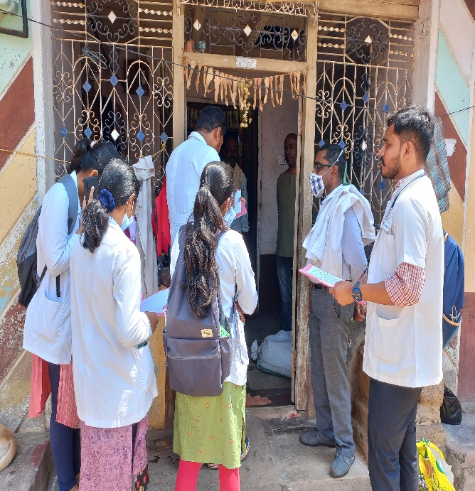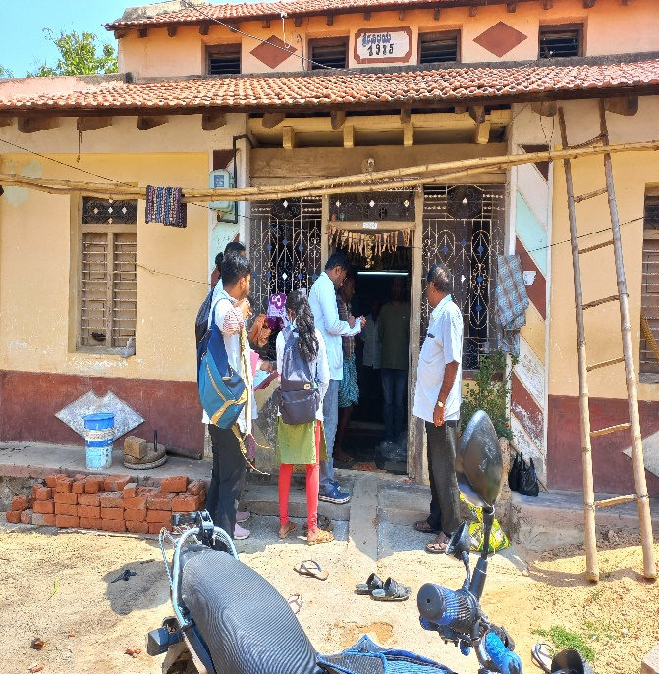

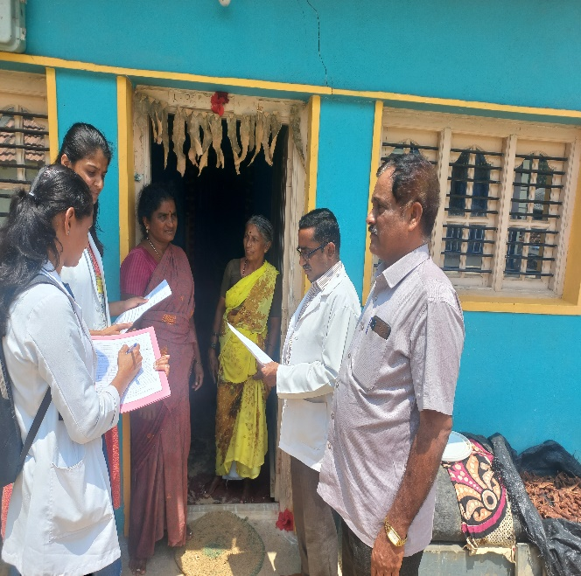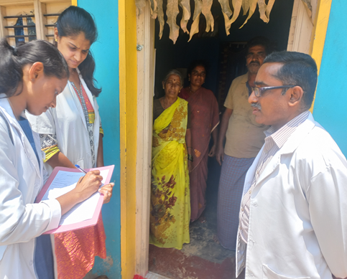
Household survey at Chakenahalli with the help of Interns.

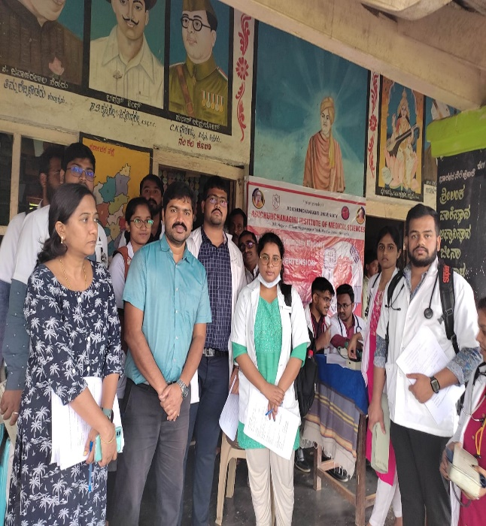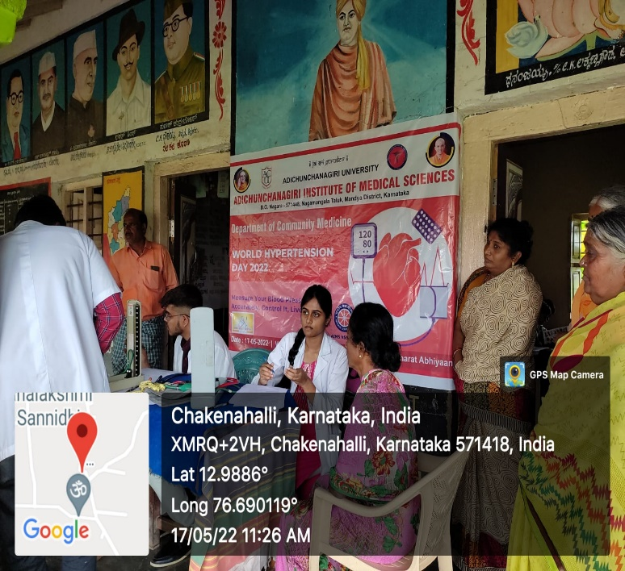

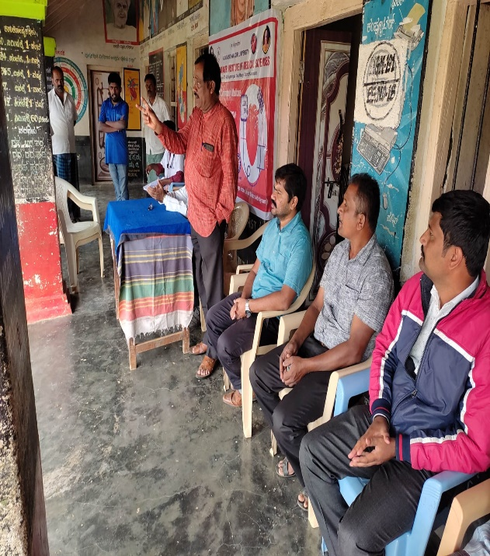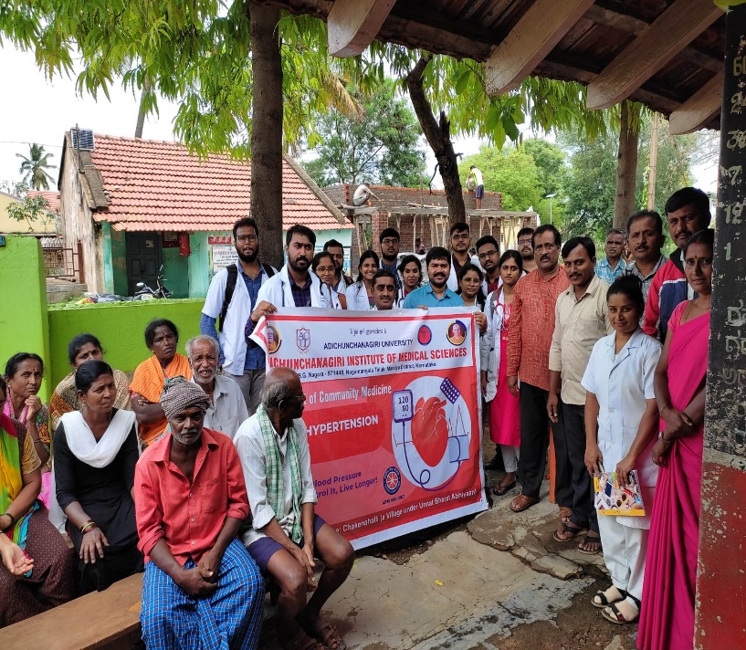

Hypertension detection camp organized at Chakenahalli

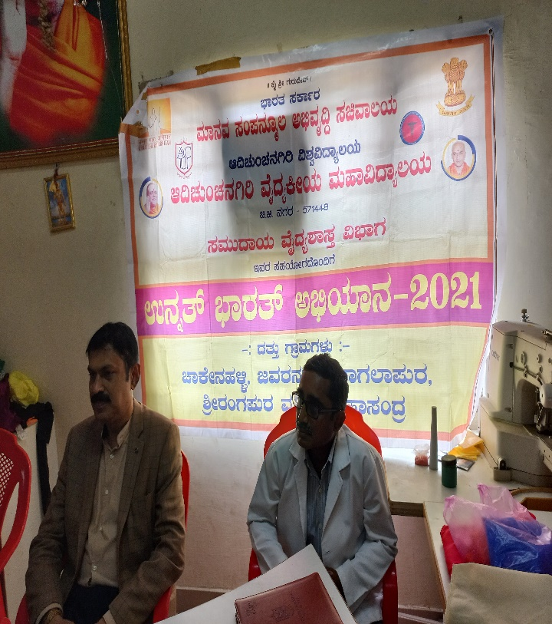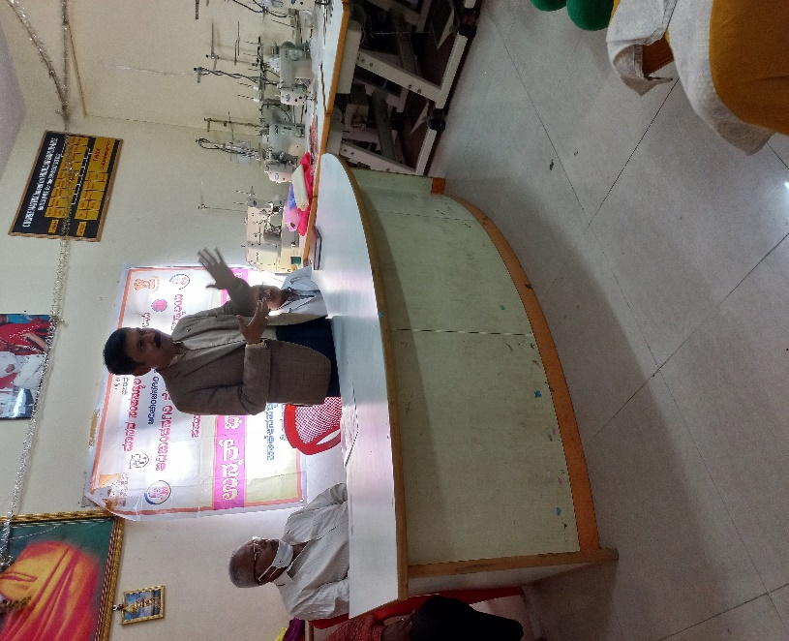

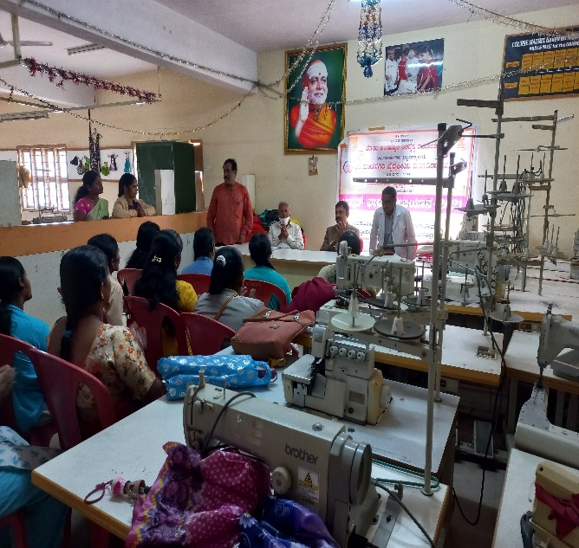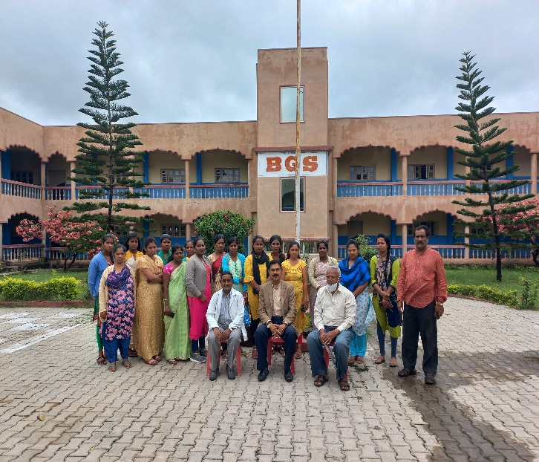
Inauguration of Tailoring Training workshop at Vocational Training Centre for ladies of Srirangapura

