Dept of Obstetrics & Gynaecology
Free Health Check-Up Camp for Women
A free health check-up camp for women was organised by the Dept of Obstetrics and Gynaecology, AH and RC in association with Kidwai Memorial Cancer Hospital, Bengaluru on 6th Sept 2022.
The camp was inaugurated by Dr M G Shivaramu, Dean, Health Sciences, ACU, Principal, AIMS, and others present were Dr Shiva Kumar K M, Chief of Hospital, Dr B G Sagar, Medical Superintendent, Dr Ravindra S Pukale, Prof & Head, Dept of OBG, Mr Umesh B K, Registrar, AIMS and Mrs Divya, Supervisor, Women and Child Welfare Dept.
A team of doctors from Dept of OBG, AIMS and nursing staff from Kidwai, postgraduates and house surgeons of Dept of OBG and Anganawadi workers from Bellur, Chunchanagiri and Kadabahalli divisions were present and educated about women health & its importance . All the beneficiaries of the camps were educated about Menstrual hygiene, symptoms of carcinoma cervix and sexually transmitted diseases, Self breast examination and screening for Cervical cancer.
An awareness programme about nutrition was also oragnised and various traditional nutritious delicacies were exhibited.
80 women participated and were benefitted from this camp.
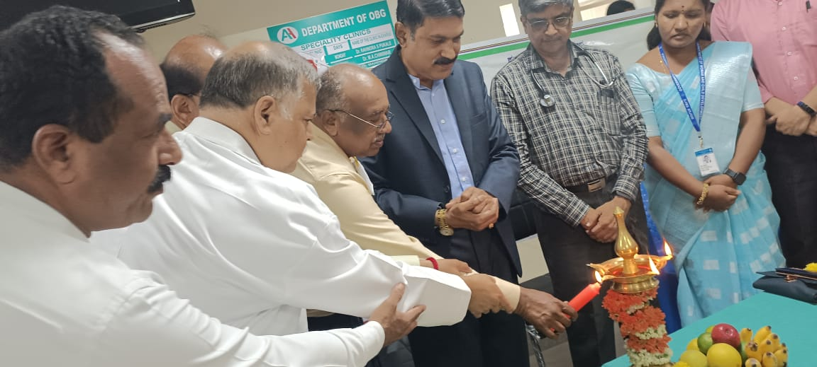

Dept of Obstetrics & Gynaecology
Free Health Check-Up Camp for Women
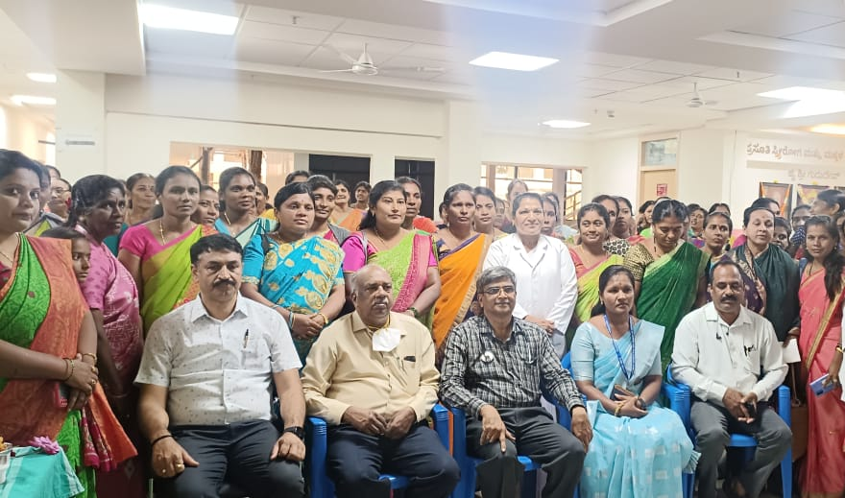

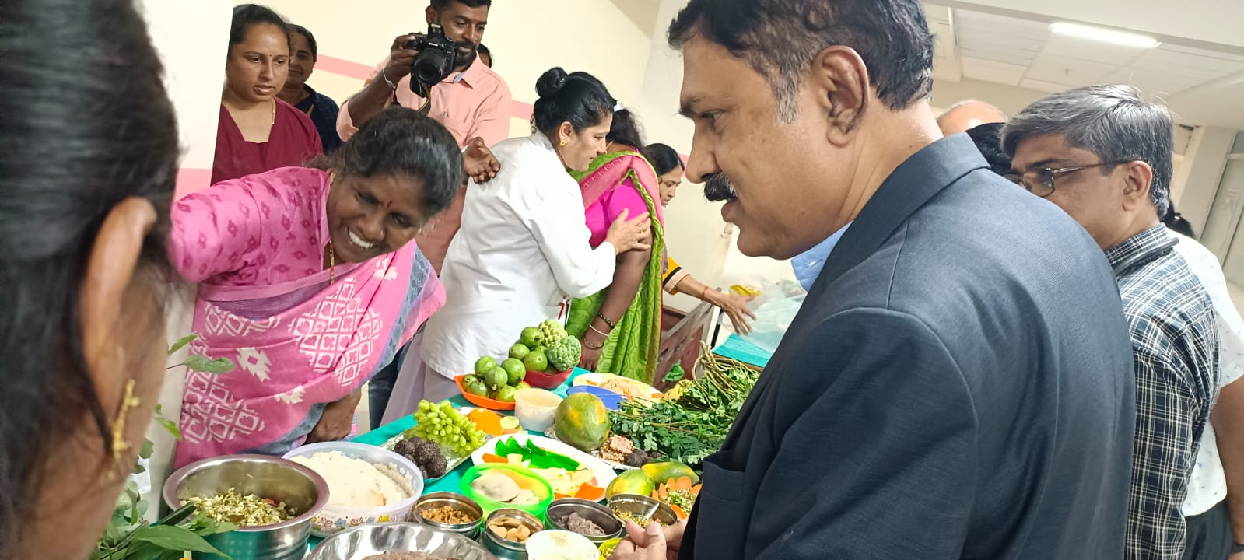

Dept of Obstetrics & Gynaecology
Free Health Check-Up Camp for Women
