ADICHUNCHANAGIRI UNIVERSITY
ADICHUNCHANAGIRI INSTITUTE OF MEDICAL SCIENCES, B.G.NAGARA-571448
DEPARTMENT OF MICROBIOLOGY
GUEST LECTURE REPORT

A guest lecture on “Role of Microbiologists in Pandemic Management” was organized by Department of Microbiology, AIMS, B G Nagara on 15.10.2022 from 11.00 am to 01.00 pm. Dr. S M Rudresh, Associate Professor of Microbiology, ESIC MC PGIMSR & MH Rajajinagar, Bangalore was the guest speaker. The function was attended by nearly 150 participants including MBBS students and Faculty.
The programme was anchored by Ms. Manisha & Ms. Manusmitha M Phase II MBBS Students. Invocation was rendered by Ms. Ananya N M & Ms. Anvitha K A
Dr. Dhanalakshmi T A, Professor of Microbiology welcomed the gathering. Dr. Venkatesha D, Professor & Head felicitated the Guest speaker. Dr. Vijaya S, Associate Professor of Microbiology introduced the speaker.
The speaker explained the history of Microbiology, important pandemics over the time line, and discussed in detail the general role and specific role of Microbiologists in Pandemic Management with an example of COVID-19 Pandemic. Feedback on the programme was taken using google form.
The programme was concluded with vote of thanks by Mrs. Rashmi S B, Tutor of Microbiology.
Majority of the participants appreciated the topic, quality of the lecture and arrangements.

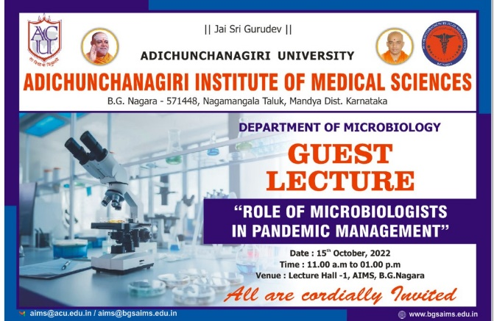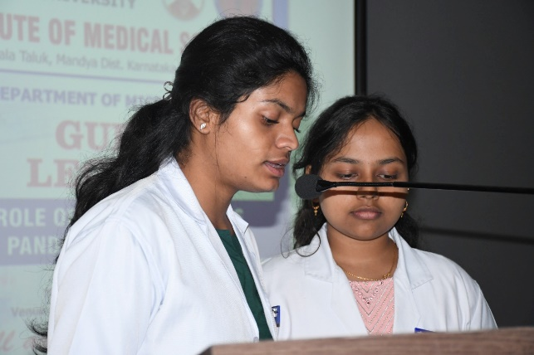
Anchor- Ms. Manisha, Ms. Manusmitha M
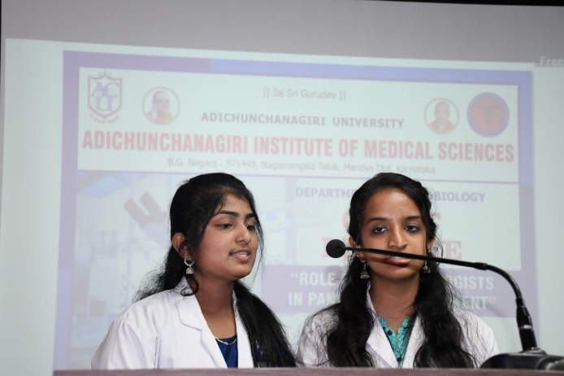
Invocation- Ms. Ananya N M, Ms. Anvitha K A Welcome address- Dr. Dhanalakshmi T A

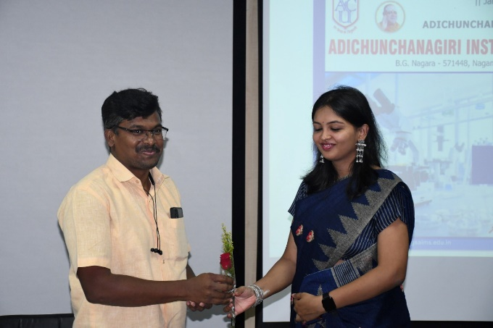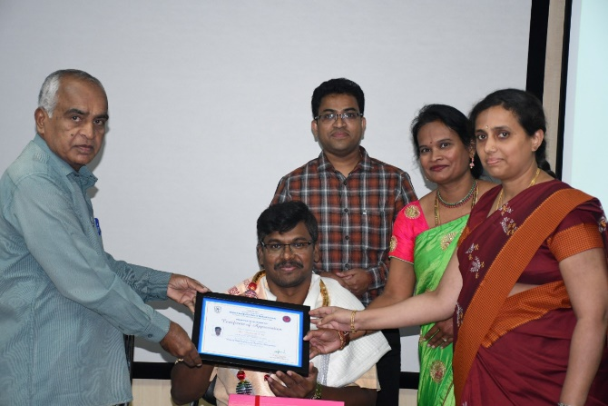
Felicitation of Guest Speaker
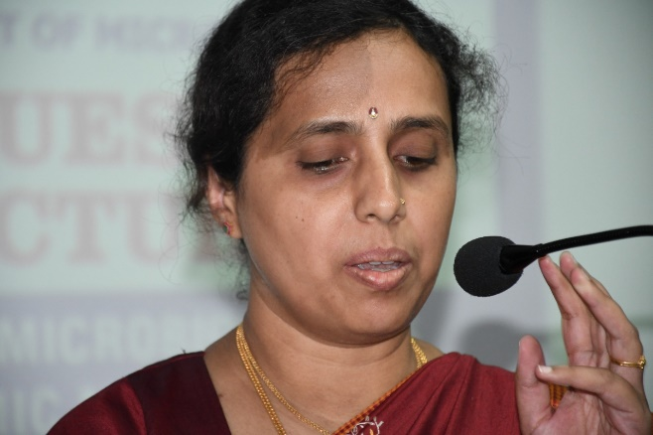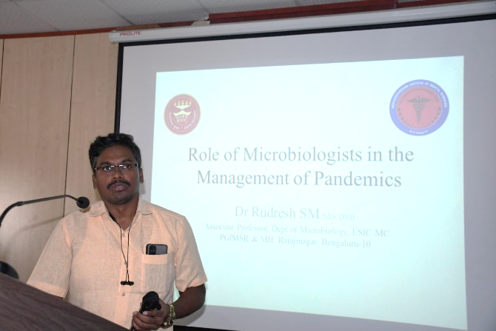
Speaker Introduction -Dr. Vijaya S Scientific Session – Dr. S M Rudresh

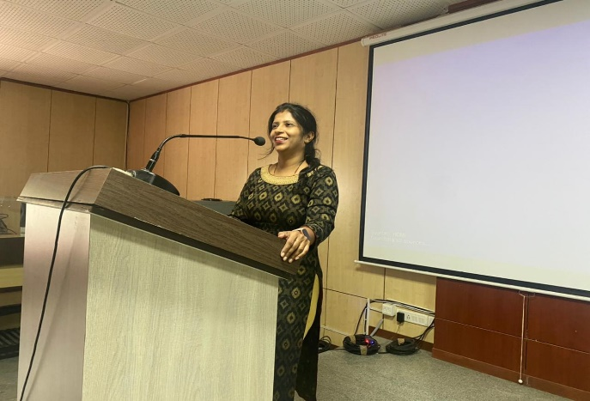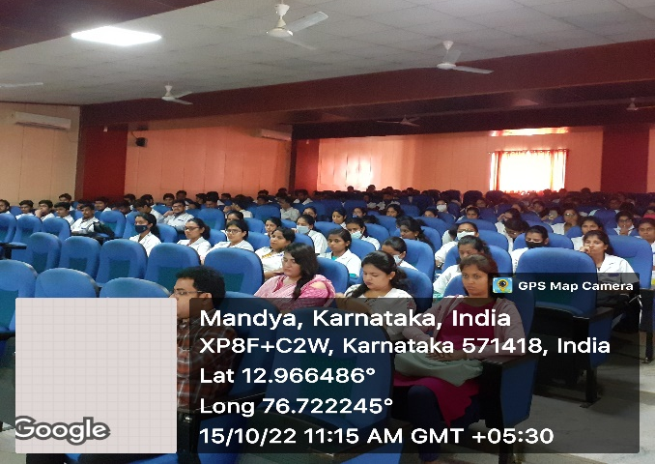
Vote of thanks- Mrs. Rashmi S B Students

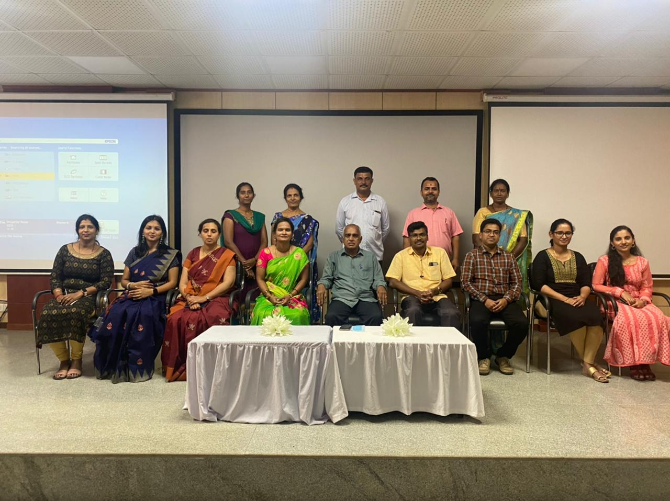
Microbiology Staff with Guest Speaker

