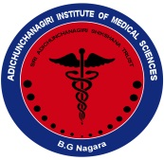
|| Jai Sri Gurudev||
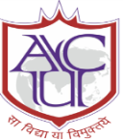ADICHUNCHANAGIRI INSTITUTE OF MEDICAL SCIENCES, B.G.Nagara- 571448
Adichunchanagiri University

Report of the “World Food Day”
20th October 2022

Department of Community Medicine in association with AIMS NSS unit jointly organised "Awareness program" on 20th October 2022 on the occasion of World Food Day, between 11:00 am to 1:00 pm at Kembare High School, Nagamangala Taluk, Mandya District. The program involved around 130 students (of classes 8th, 9th and 10th ) who actively participated in the event.
The objective of the program was to create awareness among the students about healthy and nutritious diet for all. The program started with welcoming address by the Headmaster of the school and he also addressed the gathering emphasizing the importance of World Food Day.
Following this Dr. Manuja LM, Coordinator, Student support cell, Assistant professor, Department of Community Medicine spoke regarding healthy eating habits and wastage of food and created awareness among the students .
This session was followed by a skit, performed by NSS volunteers (MBBS students of II term) where they conveyed the message about eating healthy over junk and unhealthy foods for being fit in the long run.
The third session was by Dr. Prabhudeva M.C where he spoke about the local foods and kitchen garden and importance of food hygiene. Also posters on food hygiene, balanced diet and food plate ..etc (which was prepared by 2nd Year MBBS students) were displayed at the entrance of the school to highlight the importance of food day and program ended with a vote of thanks.
All NSS volunteers and interns participated actively in the program.

