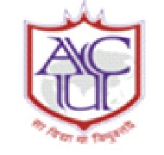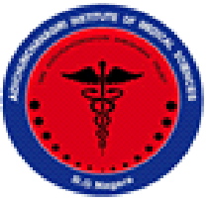
|| Jai Sri Gurudev ||
ADICHUNCHANAGIRI UNIVERSITY
ADICHUNCHANAGIRI INSTITUTE OF MEDICAL SCIENCES
Balagangadharanatha Nagara-571448

DEPARTMENT OF PHYSIOLOGY

Yoga week celebration (12th to 21st June 2023)
Jointly organized by Department of Physiology in association with APPI Bangalore chapter
Summary report (Day-1)
The Yoga week and International Day of Yoga - 2023 celebrations, were planned to fulfil the requirement of NMC to introduce Yoga training in MBBS course curriculum.

The inaugural program of Yoga week was held on 12th June, 2023 between 2.00 pm to 3.30 pm. The programme started with an invocation song by Miss. Mrudula, 1st MBBS student. The welcome address was delivered by Dr.Sudhir.G.K., Prof. HOD of Physiology, Dr.Aliya Nusrath, Vice Principal & HoD of Biochemistry and Mr.Umesh, Registrar, AIMS & Finance Officer, ACU, address the gathering. Dr.Tejaswi.H.L., HoD of Anatomy and other faculty members from Pre and Para-clinical departments were present during the occasion.
The inauguration was followed by the scientific session on the topic “Health benefits on Yoga for specific disease” by Dr.Vasanth Kumar.K.R., Professor, Department of Anaesthesiology, AIMS, who briefed about the meaning and history of Yoga and also explain the concept of health in terms of Yoga. He further emphasized specific yogic exercises for various diseases.

This session was followed by the demonstration of postures of yoga by Mr.Kumaraswamy, Yoga Instructor, AIMS along with three students of 1st MBBS, which also intended to motivate the participants to practice Yoga.

The introduction of Resource Persons of Scientific sessions was done by Dr.Anand.K.S.S., Associate Professor of Physiology, vote of thanks was proposed by Dr.Ravi.G.N., Associate Professor of Physiology Department and Dr.Keerthana and Dr.Nidha Khanam were the masters of the ceremony.

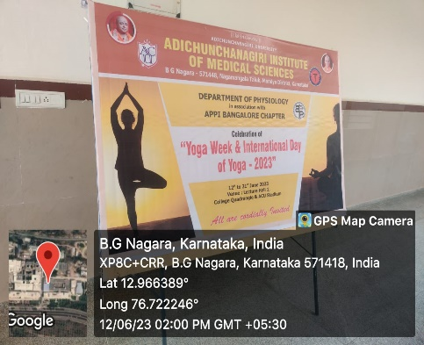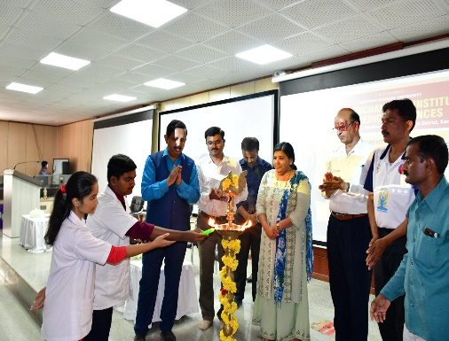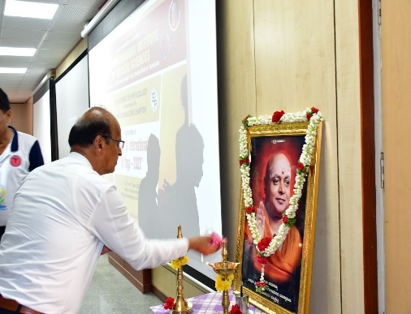
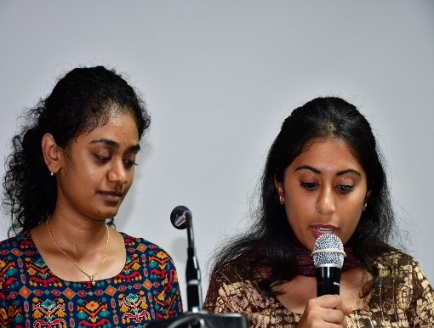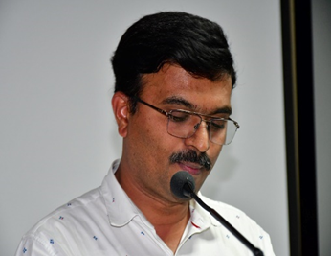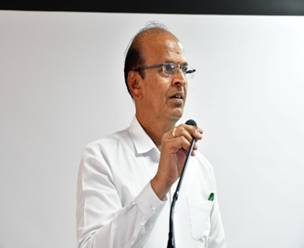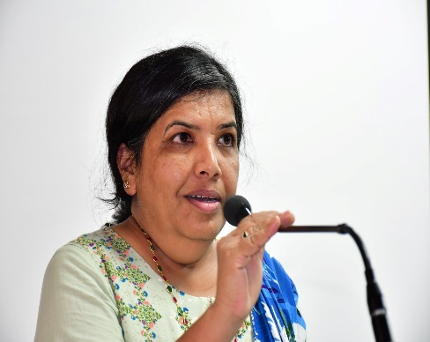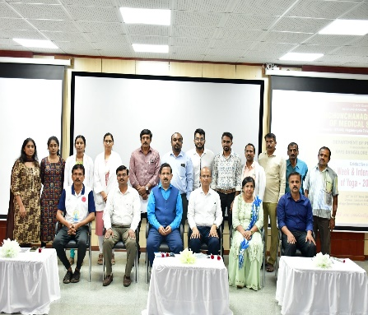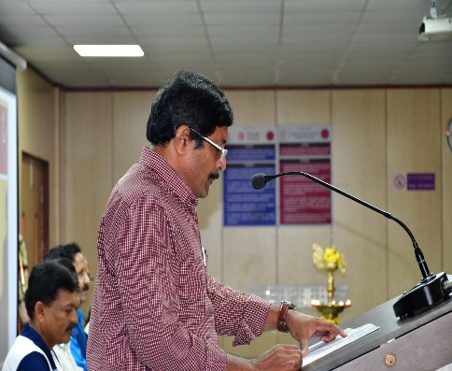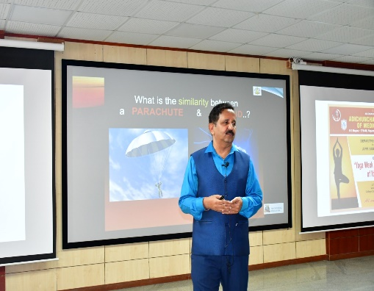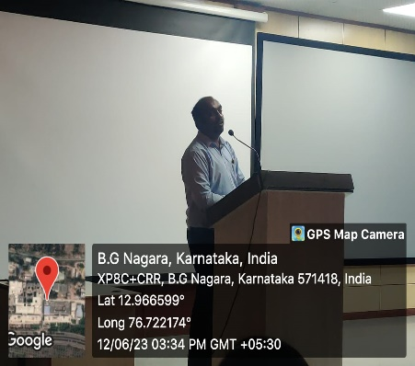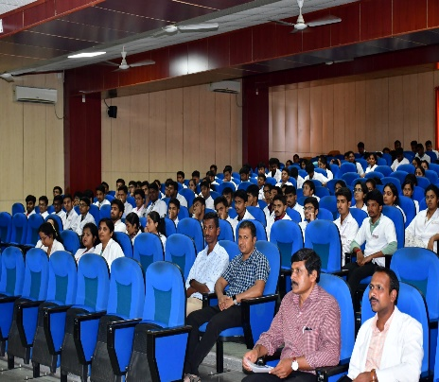
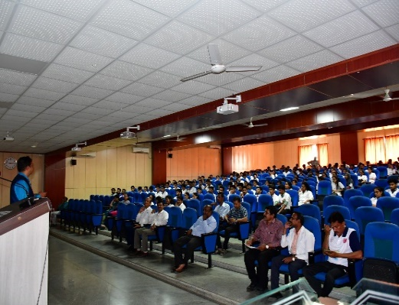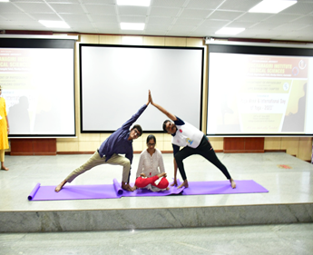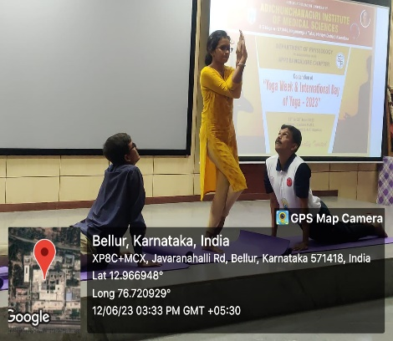

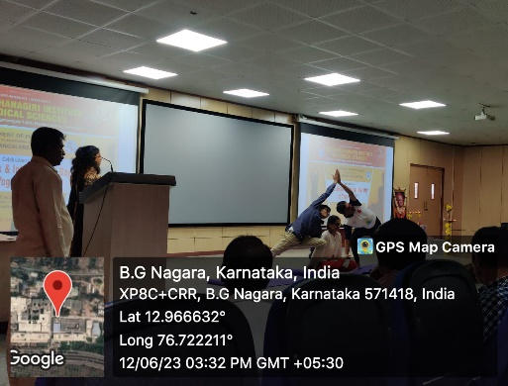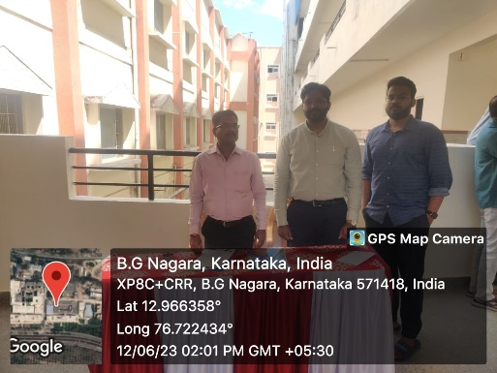

Prof. & HOD

