|| Jai Sri Gurudev ||
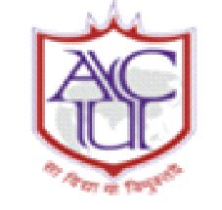 ADICHUNCHANAGIRI UNIVERSITY 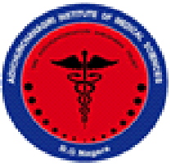
ADICHUNCHANAGIRI INSTITUTE OF MEDICAL SCIENCES
Balagangadharanatha Nagara-571448
DEPARTMENT OF PHYSIOLOGY

Yoga week celebration (12th to 21st June 2023)
Jointly organized by Department of Physiology in association with APPI Bangalore chapter
Summary report (Day-2)
The Yoga week and International Day of Yoga - 2023 celebrations, were held as per the requirement of NMC to introduce Yoga training in MBBS course curriculum.
In this regard department of Physiology had organised scientific sessions on Pranayama and Meditation on 15th June 2023 between 2.00 pm to 3.30 pm.
The program began with the invocation song by Miss. Sri Raksha Y V Ist MBBS student. Dr. Keerthana tutor in the department of Physiology welcomed the gathering. The first speaker of the program was Dr. Vijay S Hugar, Lecturer, Dept. of community Medicine who briefed about Pranayama, its origin, types. The students and the audience practiced a few techniques which the speaker demonstrated. The second session was on “Health benefits of meditation with emphasis on meditation for specific diseases” by Dr. Vasanth Kumar K. R., Professor, Department of Anaesthesiology. He also briefed about the Super Brain Yoga and benefits of meditation. The program was concluded by Vote of thanks by Dr. Sudhir G.K. Prof. & Head, Department of Physiology.

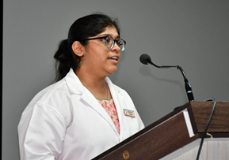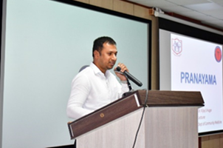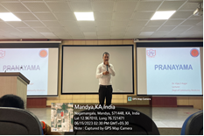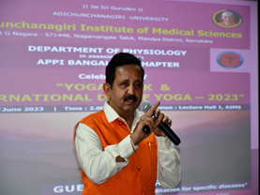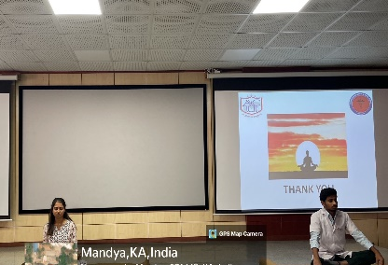

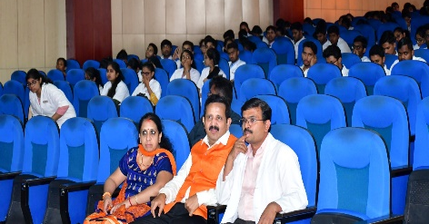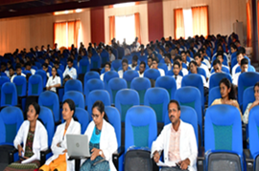

Professor and Head
Department of Physiology

